Angular provides a robust testing framework, and there are several tools and libraries commonly used for unit testing in Angular applications. The main testing tools for Angular are:

**Jasmine:**

* + **Description:** Jasmine is a behavior-driven development (BDD) testing framework for JavaScript. It is the default testing framework used with Angular.
  + **Key Features:**
    - Provides a clean and expressive syntax for writing tests.
    - Supports various matchers for expectations.
    - Can be extended with custom matchers.

**Karma:**

* + **Description:** Karma is a test runner for JavaScript that is widely used in the Angular ecosystem. It allows you to execute tests in various browsers.
  + **Key Features:**
    - Integrates with Jasmine by default (though it supports other testing frameworks).
    - Provides a development server for running tests in real browsers.
    - Can watch files for changes and rerun tests automatically.

**Protractor:**

* + **Description:** Protractor is an end-to-end testing framework for Angular applications. While it's often associated with e2e testing, it can also be used for unit testing Angular components.
  + **Key Features:**
    - Designed specifically for Angular applications.
    - Supports automatic waiting for Angular asynchronous operations.
    - Can interact with elements using Angular-specific locators.

**Angular Testing Utilities:**

* + **Description:** Angular itself provides a set of testing utilities that make it easier to test Angular components, services, and other features.
  + **Key Features:**
    - **TestBed**: Used to configure and create instances of Angular testing modules.
    - **ComponentFixture**: Wraps a component for testing and provides access to the component's instance and the component's native element.

**Jest:**

* + **Description:** While Jasmine and Karma are commonly used in the Angular ecosystem, Jest is another popular testing framework that can be used for Angular applications.
  + **Key Features:**
    - Zero configuration by default (but can be customized).
    - Provides a fast and parallel test runner.
    - Supports snapshot testing.

When setting up an Angular project, the default configuration includes Jasmine and Karma. You can use the Angular CLI to generate tests and run them using Karma. Additionally, you can customize your testing setup based on your project's requirements.

To use these tools effectively, it's essential to understand the concepts of unit testing, testing modules, services, components, and dealing with dependencies in an Angular context.

UNIT TESTING::

Angular provides a robust testing framework, and there are several tools and libraries commonly used for unit testing in Angular applications. The main testing tools for Angular are:

Jasmine:

Description: Jasmine is a behavior-driven development (BDD) testing framework for JavaScript. It is the default testing framework used with Angular.

Key Features:

Provides a clean and expressive syntax for writing tests.

Supports various matchers for expectations.

Can be extended with custom matchers.

Karma:

Description: Karma is a test runner for JavaScript that is widely used in the Angular ecosystem. It allows you to execute tests in various browsers.

Key Features:

Integrates with Jasmine by default (though it supports other testing frameworks).

Provides a development server for running tests in real browsers.

Can watch files for changes and rerun tests automatically.

Protractor:

Description: Protractor is an end-to-end testing framework for Angular applications. While it's often associated with e2e testing, it can also be used for unit testing Angular components.

Key Features:

Designed specifically for Angular applications.

Supports automatic waiting for Angular asynchronous operations.

Can interact with elements using Angular-specific locators.

Angular Testing Utilities:

Description: Angular itself provides a set of testing utilities that make it easier to test Angular components, services, and other features.

Key Features:

TestBed: Used to configure and create instances of Angular testing modules.

ComponentFixture: Wraps a component for testing and provides access to the component's instance and the component's native element.

Jest:

Description: While Jasmine and Karma are commonly used in the Angular ecosystem, Jest is another popular testing framework that can be used for Angular applications.

Key Features:

Zero configuration by default (but can be customized).

Provides a fast and parallel test runner.

Supports snapshot testing.

When setting up an Angular project, the default configuration includes Jasmine and Karma. You can use the Angular CLI to generate tests and run them using Karma. Additionally, you can customize your testing setup based on your project's requirements.

To use these tools effectively, it's essential to understand the concepts of unit testing, testing modules, services, components, and dealing with dependencies in an Angular context.

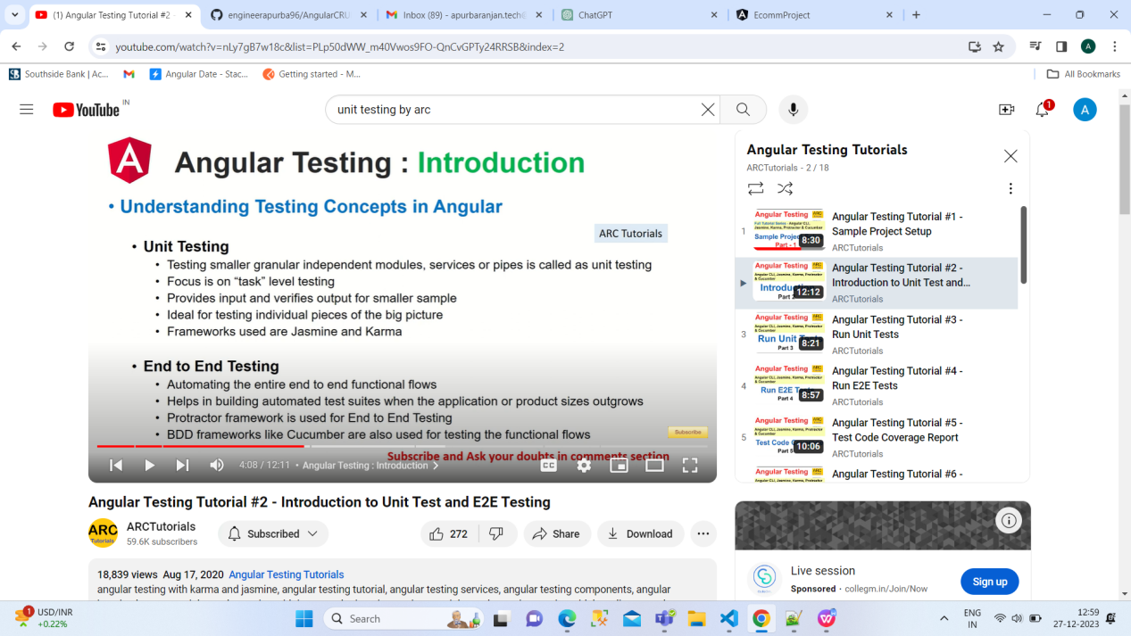

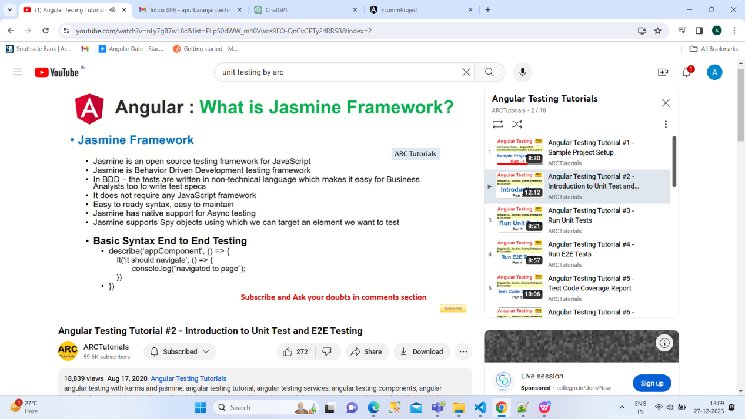

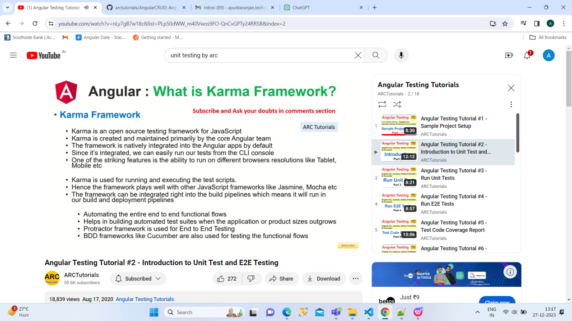

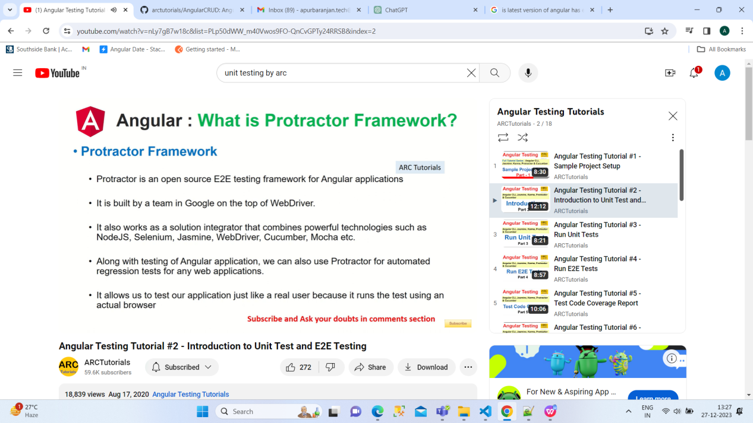

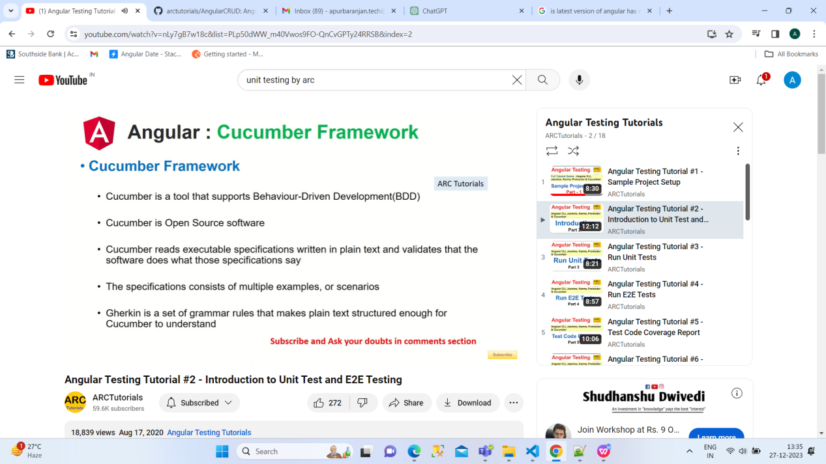

**Unit Test:**

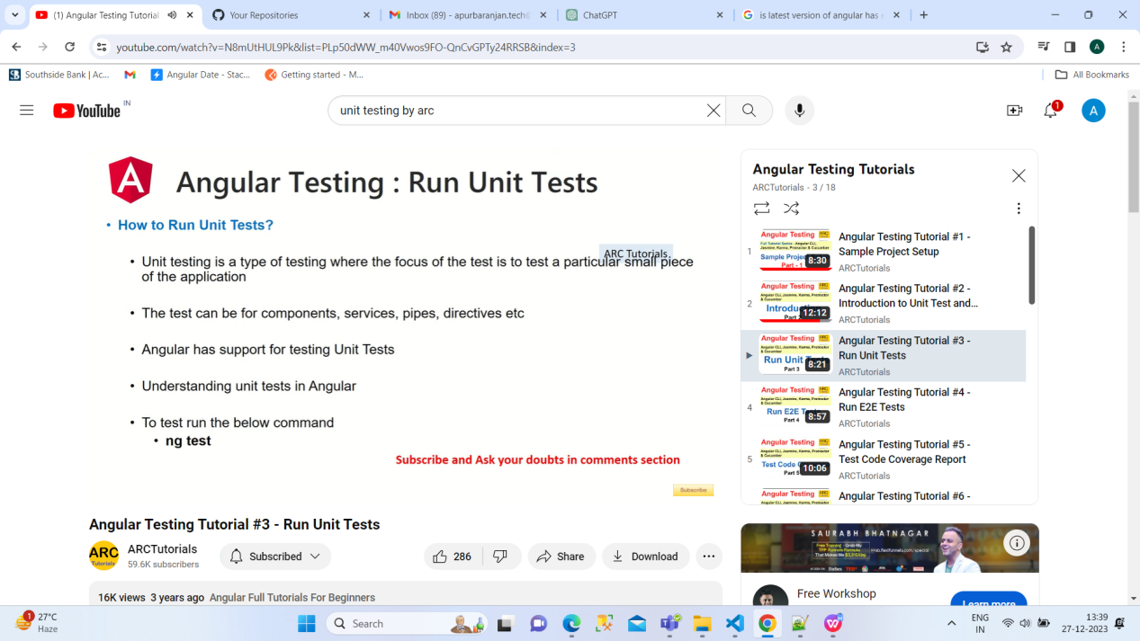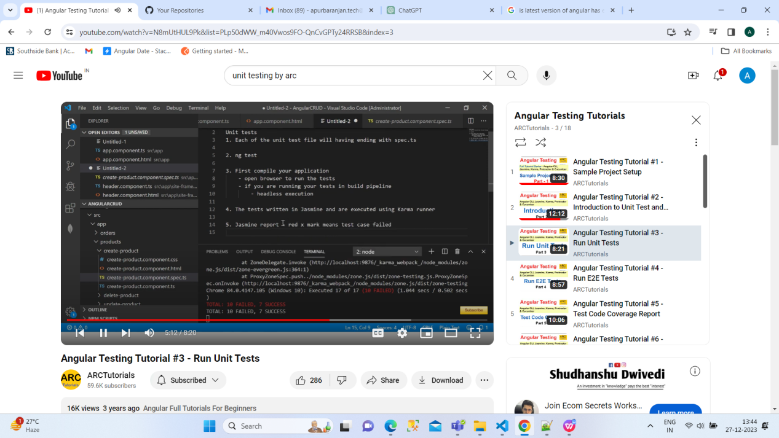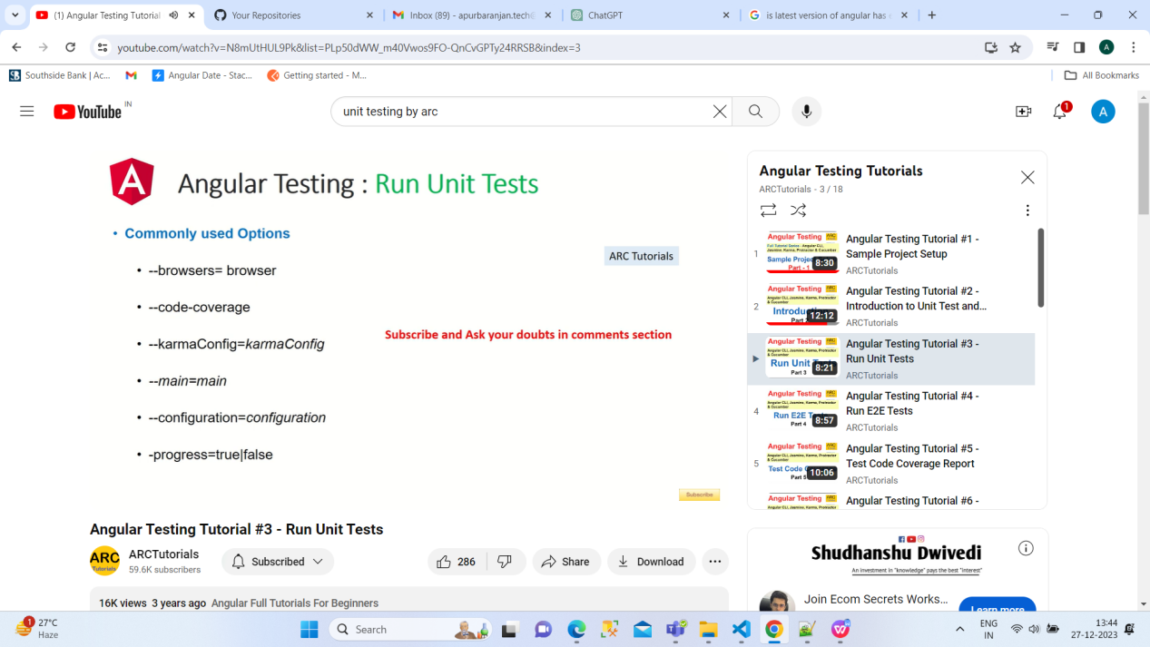

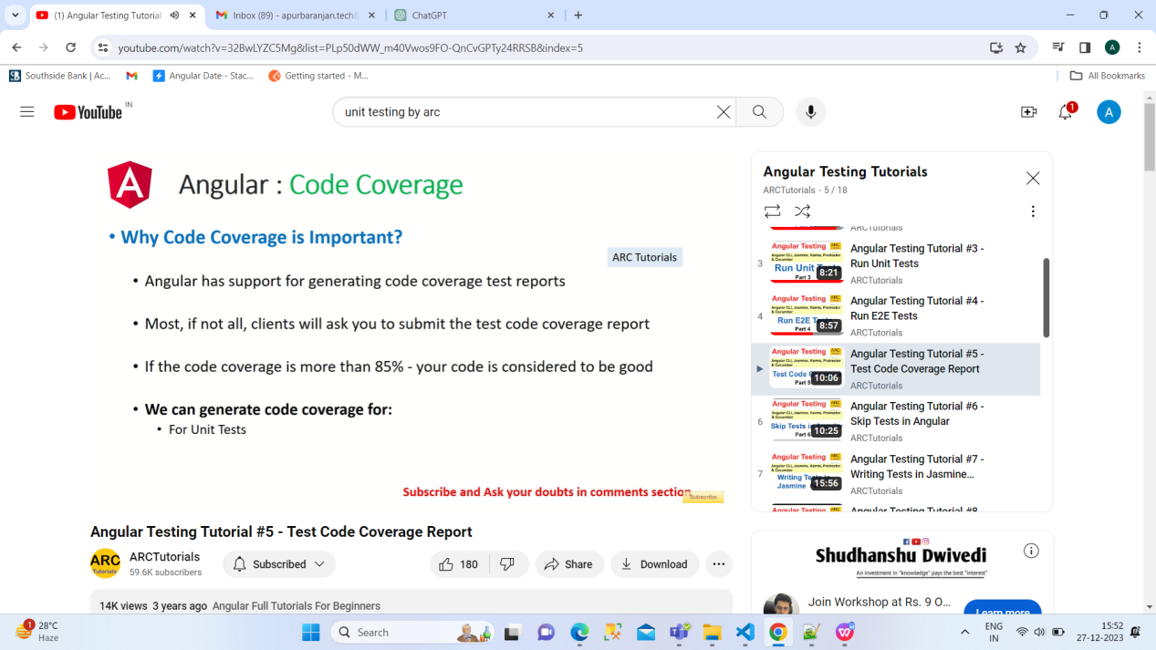

Code coverage in unit testing refers to the percentage of your codebase that is exercised by your tests. It helps you understand how much of your code is being tested and can be a valuable metric for assessing the thoroughness of your test suite. In Angular, code coverage is often measured using tools like Istanbul or the built-in coverage tools in popular testing frameworks.

Code coverage is for unit test only.

* ng test --code-coverage=true ---It means we need code coverage for current application

How to skip:

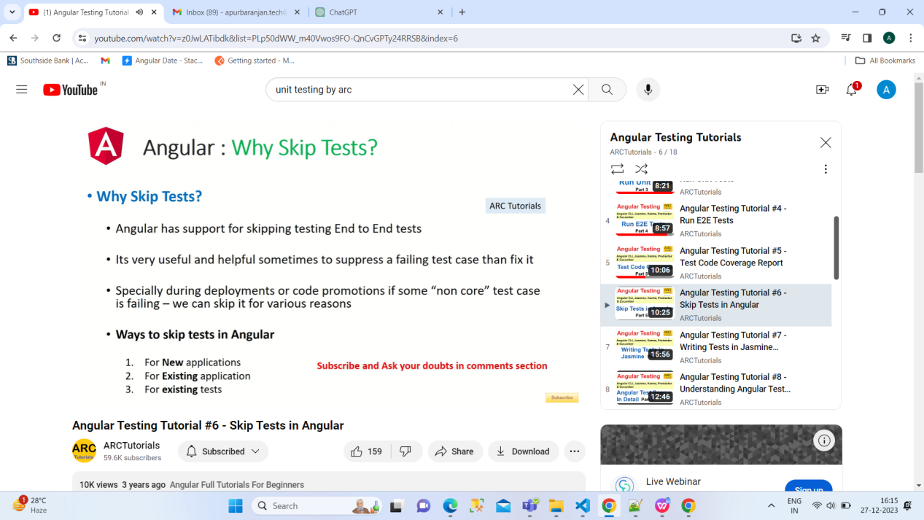

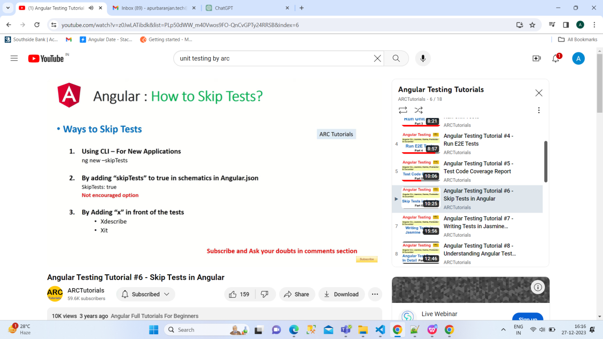

This for new

ng new projectname --skipTests

For old:

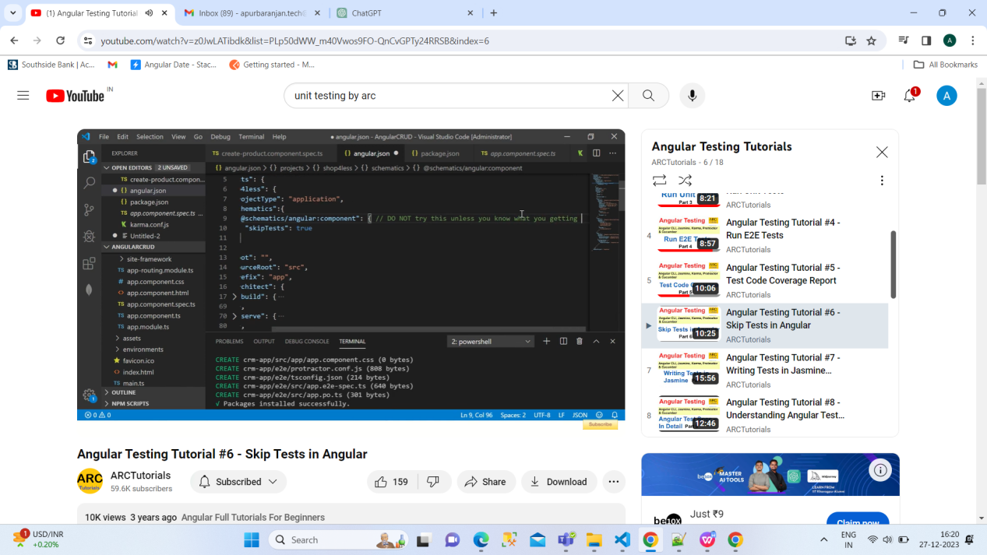

Basic Concept:

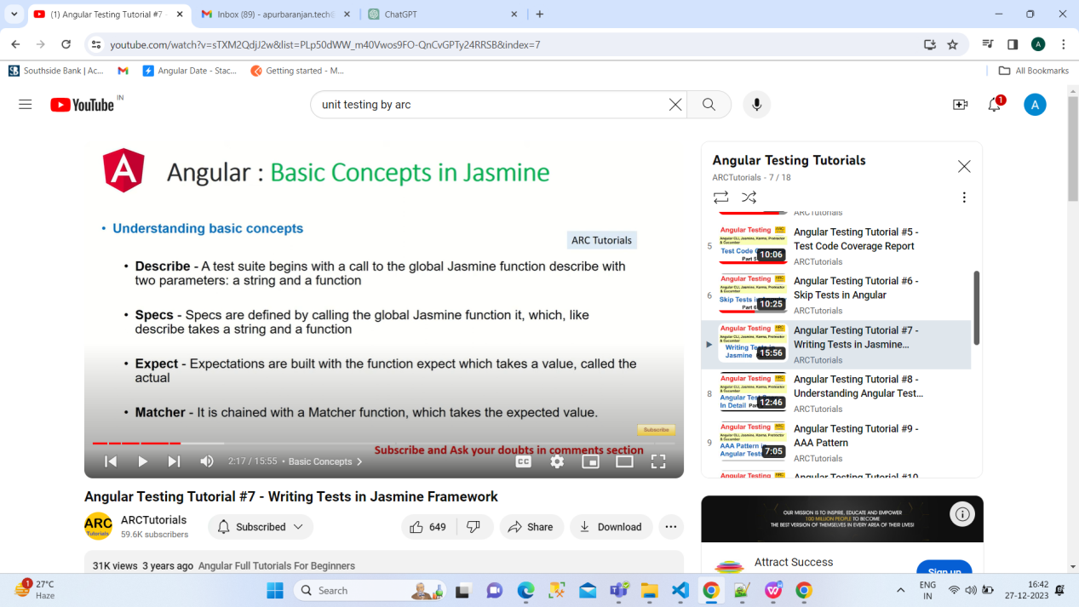

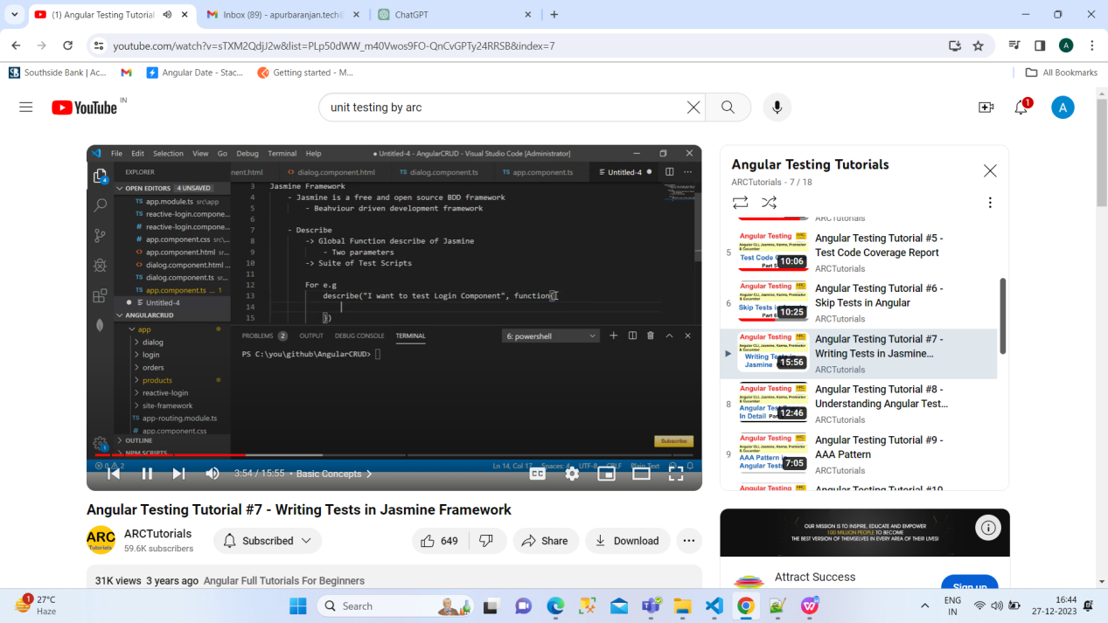

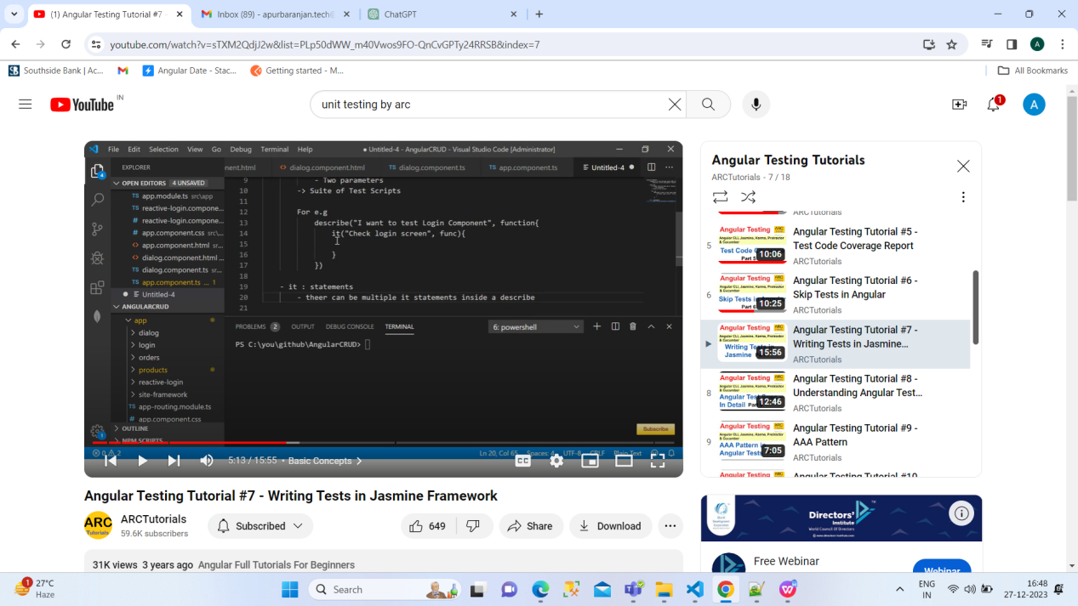

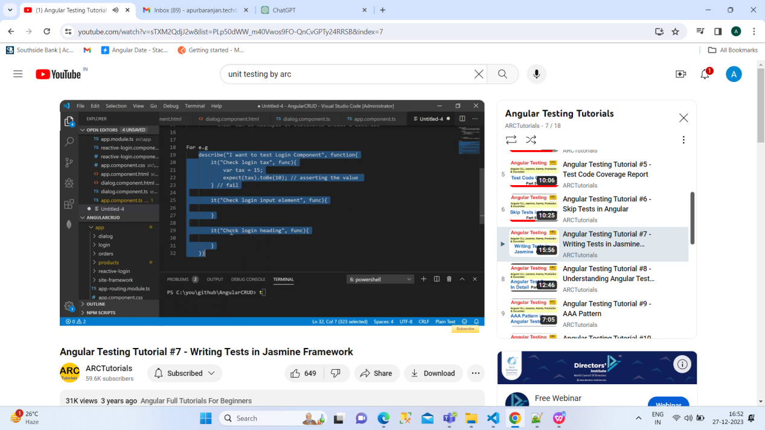

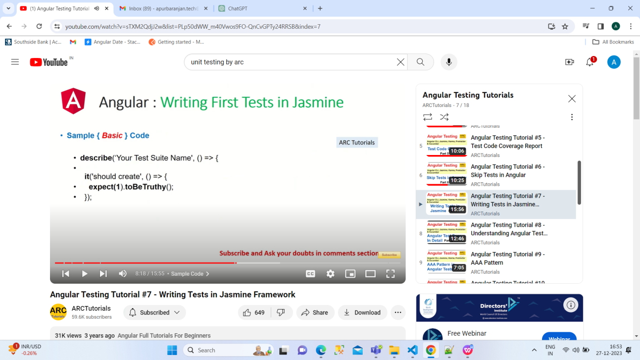

If we will put f in describe it meanse focused describe

Fdescribe

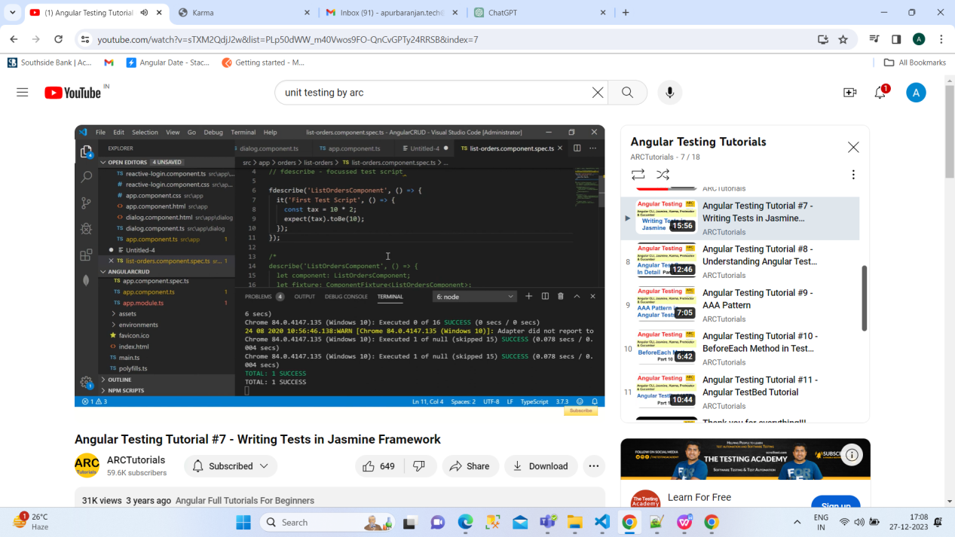

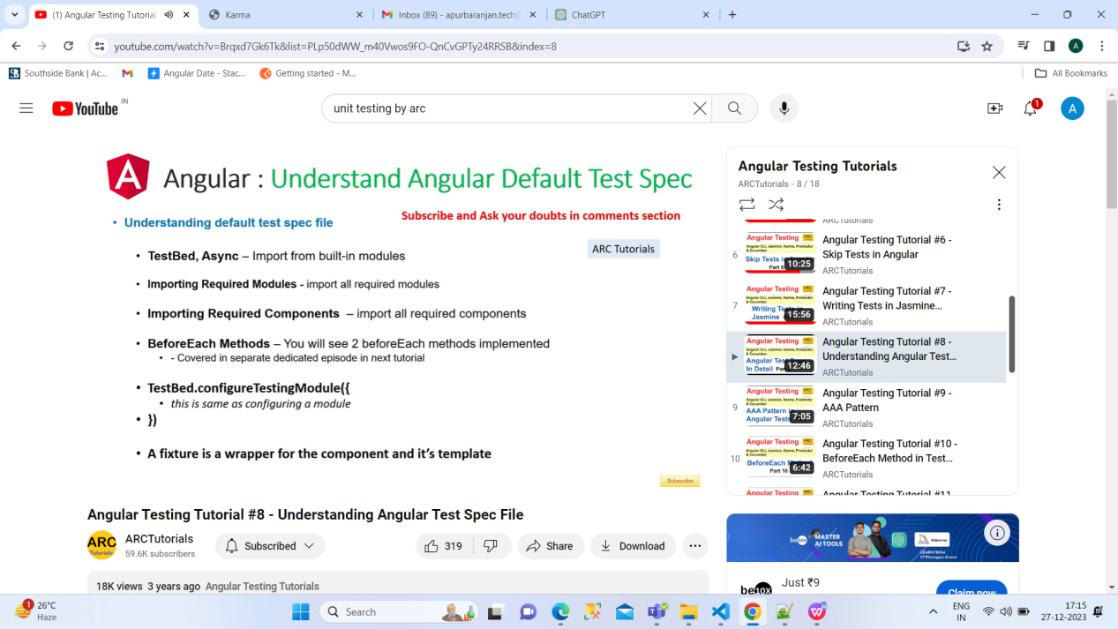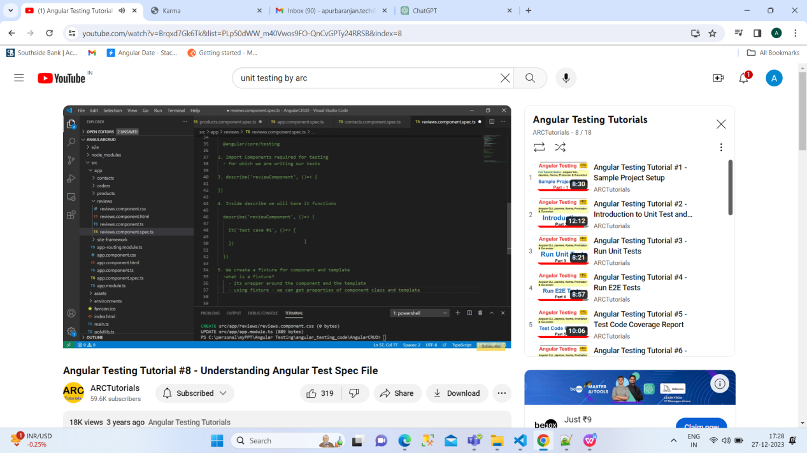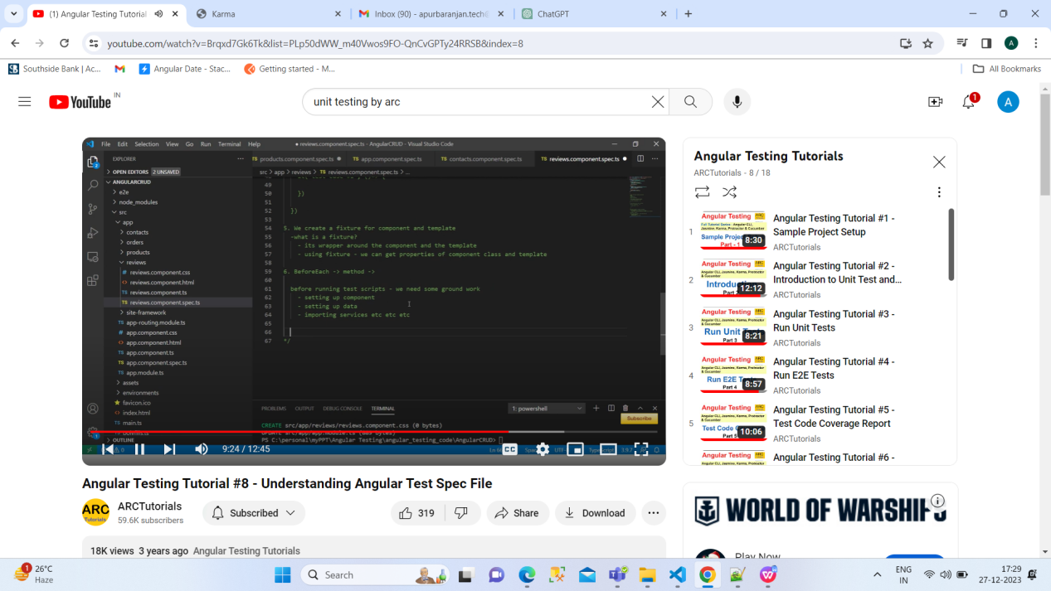

AAA:

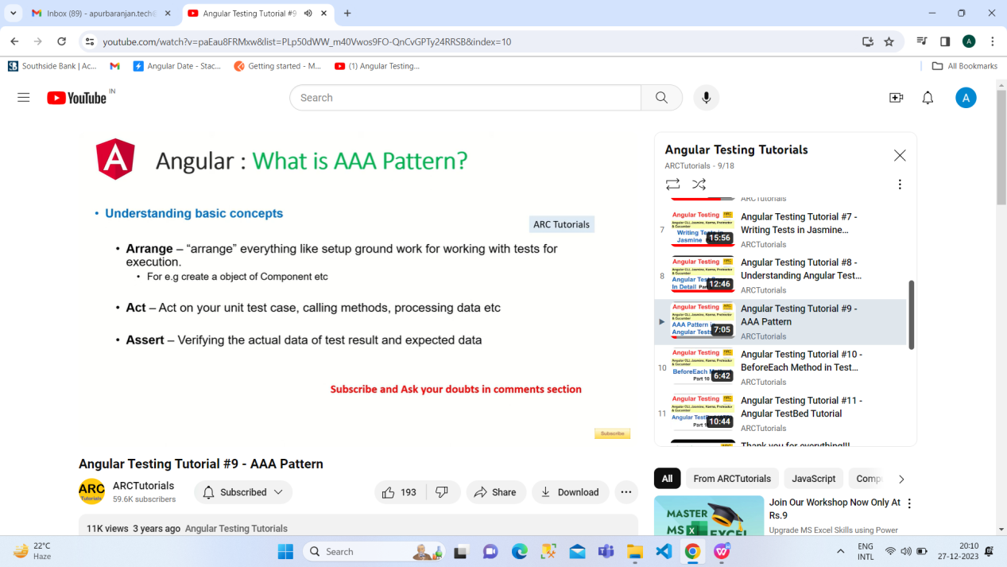

AAA stands for: Arrange, Act, Assert. This is a commonly taught structure for unit tests. This structure guides us in how to "arrange" our tests, and is generally considered to produce tests that are easier to maintain.

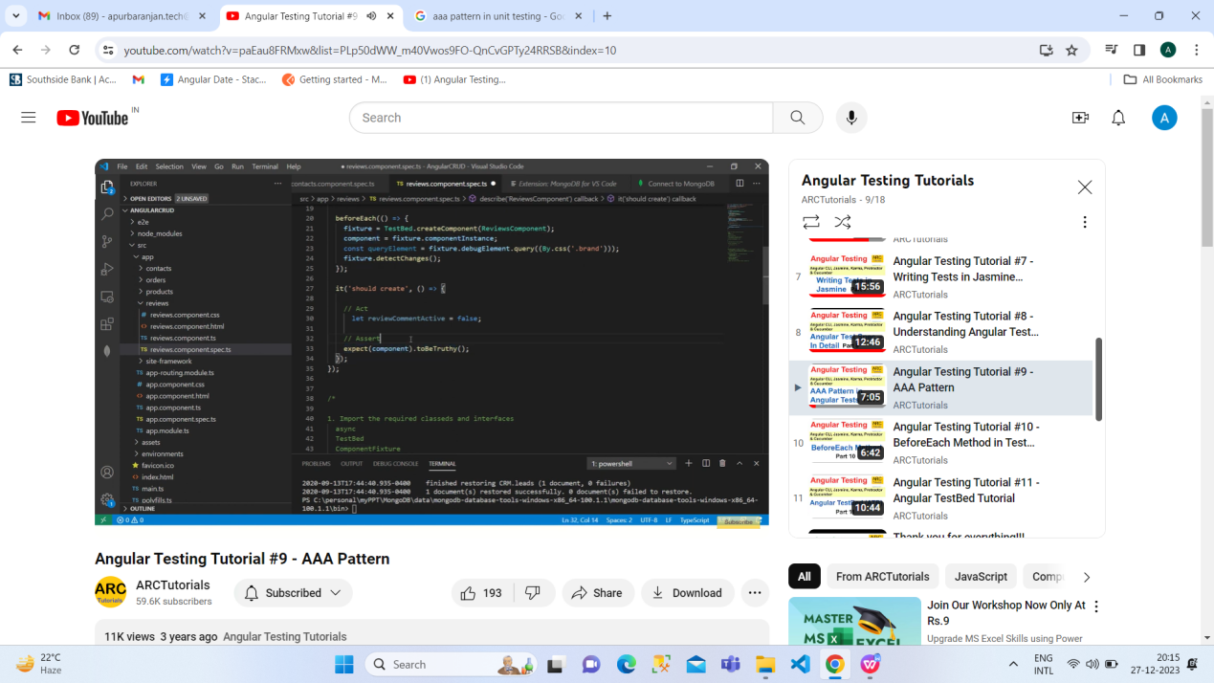

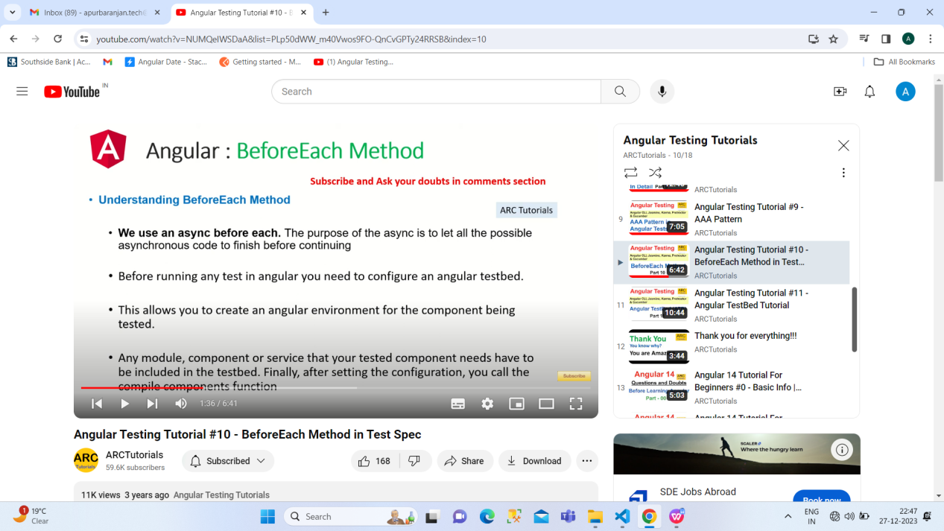

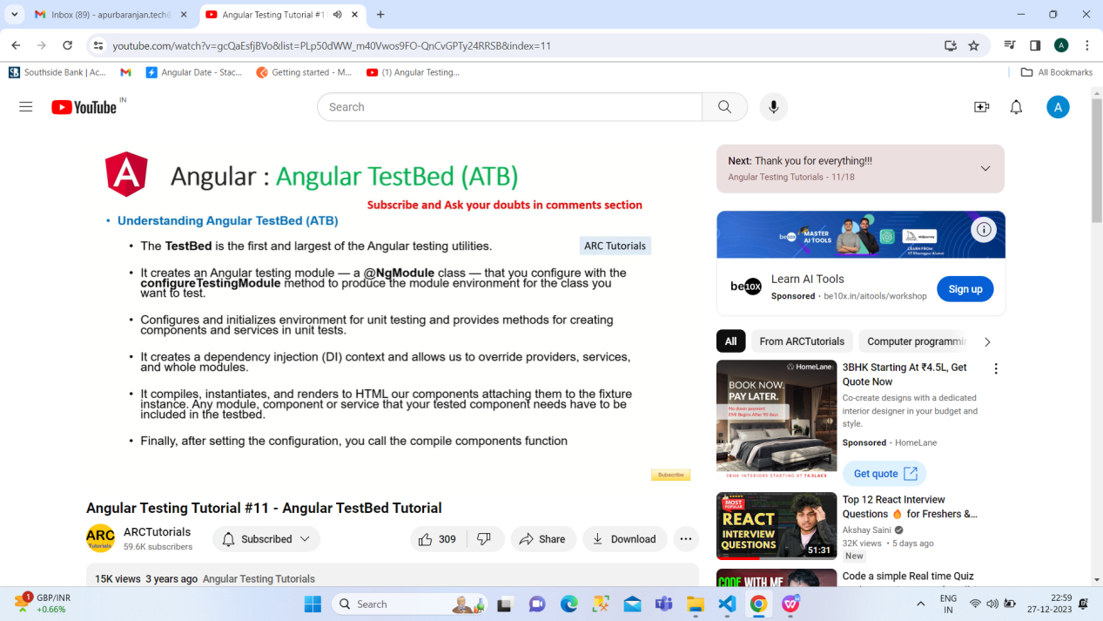

<div *ngIf="hero" class="name">{{hero.name}}</div>

    <ng-template [ngIf]="hero">

      <div class="name">{{hero.name}}</div>

    </ng-template>

First one is correct but 2 nd one is convert from 1st.\

const user = {

    name: 'Tyler',

    age: 27,

    greet: () => {

      console.log(`Hello, my name is ${this.name}`);

    }

  }

 user.greet();

;

Arrow function doesn’t support this.

const a={};

const b= JSON.stringify(a);

console.log(a===b);

False

Q.

const a={};

const b= a;

console.log(a==b);//true

const a={};

const b= {};

console.log(a==b);

False

const a={};

const b= {};

console.log(a===b);

False

const a={};

const b= a;

console.log(a==b)

True

The choice between Angular and React often depends on the specific requirements of a project, the expertise of the development team, and the preferences of the developers. Both Angular and React are popular JavaScript frameworks/libraries for building web applications, but they have different philosophies, features, and use cases. Here are some reasons why one might prefer Angular over React:

**Full-Featured Framework:**

* + Angular is a comprehensive and opinionated framework that comes with a lot of built-in features and tools, such as a powerful templating engine, dependency injection, and a complete set of tools for building large-scale applications. React, on the other hand, is more of a library focused on the view layer.

**Two-Way Data Binding:**

* + Angular uses two-way data binding, which means that changes in the model automatically update the view and vice versa. This can lead to less boilerplate code for managing the state and updating the UI.

**Dependency Injection:**

* + Angular has a built-in dependency injection system, which helps manage the components and their dependencies. This can make it easier to manage and test components.

**TypeScript Support:**

* + Angular is built with TypeScript in mind, and it's the primary language for Angular development. TypeScript is a superset of JavaScript that adds static typing, interfaces, and other features, which can help catch errors during development.

**Integrated Toolset:**

* + Angular provides a more integrated toolset out of the box. It includes tools like Angular CLI (Command Line Interface) for generating components, services, and more. React, being a library, often requires additional third-party tools and libraries for certain functionalities.

**Official Opinion on Architecture:**

* + Angular provides a more prescriptive approach to application architecture. It comes with a set of conventions and guidelines that can be beneficial, especially for large teams working on complex projects. React, being a library, allows more flexibility, which can be an advantage or a disadvantage depending on the project and team.

**Strong Enterprise Support:**

* + Angular is developed and maintained by Google, which can provide a sense of stability and long-term support for enterprise-level applications. React is developed and maintained by Facebook and has strong community support, but the backing of a large company like Google may be a factor in some enterprise decisions.

It's important to note that both Angular and React have their strengths and weaknesses, and the choice between them often comes down to the specific needs and preferences of the development team and the requirements of the project. Some developers may prefer the flexibility and simplicity of React, while others may appreciate the structure and features provided by Angular. Ultimately, both frameworks/libraries are capable of building powerful and scalable web applications.

Q1.how to check component,how much size it has taken in dom

Q2.how to check what modules take and how much size in prod bundle

Ans of q1 and q2: <https://www.youtube.com/watch?v=Lu-wzIbMTpo> <https://www.npmjs.com/package/webpack-bundle-analyzer>

angula18 uses VITE instead of webpack to build

CORS (Cross-Origin Resource Sharing) is a security feature implemented by web browsers to prevent web pages from making requests to a different domain than the one that served the web page. It is a browser security feature that protects users by restricting web pages from making requests to a different domain than the one that served the web page.

In the context of Angular applications, CORS errors typically occur when your Angular application, running in one domain (e.g., http://localhost:4200), tries to make a request to an API endpoint hosted on a different domain (e.g., http://api.example.com). Browsers enforce the Same-Origin Policy, and if the server hosting the API does not explicitly allow requests from your Angular application's domain, the browser will block the request and generate a CORS error.

The CORS error usually looks like this in the browser console:

**Uplers**

Q1.explain how you would implement a features that requires simultaneous changes in the html,css and javascript files to deliver a single cohesive unit?

AnsImplementing a feature that requires simultaneous changes in HTML, CSS, and JavaScript involves coordinating changes across these three components to ensure they work seamlessly together. Let's break down the process:

1. **Identify the Feature Requirements:**
   * Clearly define the requirements of the feature you want to implement.
   * Understand what elements need to be modified or added in the HTML structure.
   * Identify the styles and layout adjustments required in the CSS.
   * Determine the interactive behavior and functionality needed using JavaScript.
2. **Update HTML:**
   * Modify the HTML file to include or adjust the necessary elements for the feature.
   * Ensure proper structuring and semantics according to the HTML5 standards.
   * Add appropriate IDs or classes to elements that will be manipulated by JavaScript.
   * Make sure the HTML structure aligns with the design and functionality requirements.
3. **Update CSS:**
   * Adjust the CSS styles to accommodate the changes made in the HTML.
   * Apply styling to the new elements and modify existing styles as needed.
   * Use consistent naming conventions and follow best practices to keep the code organized.
   * Test the layout to ensure that it looks and behaves as expected.
4. **Update JavaScript:**
   * Implement the required functionality using JavaScript.
   * Select elements using their IDs or classes and apply the necessary actions or events.
   * Ensure that JavaScript code is efficient, well-organized, and follows best practices.
   * Test the interactivity to confirm that the feature works as intended.
5. **Testing:**
   * Test the feature across different browsers to ensure cross-browser compatibility.
   * Verify that the feature functions correctly on various devices and screen sizes.
   * Check for any styling issues and adjust the CSS accordingly.
   * Test the feature's behavior in different scenarios to identify and fix potential bugs.
6. **Refactoring and Optimization:**
   * Review the code for any redundancy or areas for improvement.
   * Optimize the code for performance, especially in the case of JavaScript.
   * Consider modularization to improve maintainability.
7. **Documentation:**
   * Document any significant changes, especially if the project involves multiple developers.
   * Update any relevant documentation to reflect the new feature.
8. **Version Control:**
   * If you're using version control (e.g., Git), commit your changes with clear and descriptive commit messages.
   * This makes it easier to track changes and roll back if necessary.

By following these steps, you can implement a feature that requires changes in HTML, CSS, and JavaScript in a cohesive manner, ensuring that all components work seamlessly together.

Q2. Demonstarte how you would use a content management system to deploy a change on a live website with minimam downtime?

Ans: Deploying changes to a live website using a Content Management System (CMS) can be done with minimal downtime if you follow best practices. Here's a general guide:

**1. Backup the Current State:**

* Before making any changes, create a backup of your website, including the database and files. This ensures you can revert to the previous state if anything goes wrong.

**2. Use Version Control (Optional):**

* If your CMS supports version control (e.g., Git), use it to manage your code changes. This allows you to track and roll back changes easily.

**3. Set Up a Staging Environment:**

* Create a staging environment that mirrors your live environment. This is a duplicate of your website where you can test changes before deploying them to the live site.

**4. Test Changes in Staging:**

* Apply the changes in your staging environment and thoroughly test them. This includes testing functionality, design, and any other aspects affected by the update.

**5. Implement Feature Flags (Optional):**

* If your CMS or application supports feature flags, consider using them to toggle features on and off easily. This allows you to deploy changes without making them immediately visible to users.

**6. Schedule a Maintenance Window:**

* Choose a time when your website experiences minimal traffic for the actual deployment. Inform users about the scheduled maintenance to manage expectations.

**7. Put the Website in Maintenance Mode (Optional):**

* Depending on your CMS, you may have the option to put the website in maintenance mode. This informs users that the site is temporarily unavailable during the update.

**8. Deploy Changes:**

* Apply the changes to the live environment. If you're using version control, pull the latest changes from your repository. If not, upload the updated files or apply changes through the CMS.

**9. Clear Caches:**

* Clear any caches your CMS or server might be using to ensure that users see the updated content.

**10. Test Live Changes:**

* After deploying the changes, test the live site to ensure that everything works as expected. This should be a quick validation to catch any issues introduced during deployment.

**11. Monitor for Issues:**

* Keep an eye on your website for a period after deployment to identify and address any issues that might arise.

**12. Communicate:**

* Inform your users that the maintenance is complete and the website is back online.

**13. Post-Deployment Checks:**

* Perform additional checks and monitoring to ensure that the website is stable.

**14. Rollback Plan:**

* Have a rollback plan in place in case you encounter major issues. This may involve restoring the backup created in step 1.

**15. Document Changes:**

* Update documentation to reflect the changes made to the live site.

By following these steps, you can deploy changes to a live website using a CMS with minimal downtime and a reduced risk of disruptions to user experience. Always remember to thoroughly test changes before deploying them to the live environment and to communicate effectively with your users during maintenance periods.

Q3.How do you implement SEO friendl website structure while maintaining the desired layout aesthetics using HTML and CSS?

Ans: Creating an SEO-friendly website structure while maintaining desired layout aesthetics involves a combination of best practices in HTML and CSS. Here are some guidelines to achieve this:

**1. Semantic HTML:**

* Use semantic HTML tags to provide meaningful structure to your content. This helps search engines understand the hierarchy and context of your content.
* Examples of semantic tags include **<header>**, **<nav>**, **<article>**, **<section>**, **<aside>**, and **<footer>**. Use these appropriately based on your content.

**2. Clear and Concise URL Structure:**

* Create clean and descriptive URLs for your pages. Use keywords that reflect the content of the page.
* Avoid using unnecessary parameters or complex URL structures. Keep URLs readable and user-friendly.

**3. Proper Use of Headings:**

* Organize your content with proper heading tags (**<h1>** to **<h6>**). Use them hierarchically to outline the structure of your page.
* Ensure that your main heading (**<h1>**) represents the primary topic of the page and is followed by relevant subheadings.

**4. Responsive Design:**

* Implement a responsive design using CSS media queries to ensure your website is accessible and user-friendly on various devices, including mobile phones and tablets.
* Google considers mobile-friendliness as a ranking factor, so it's crucial to have a responsive layout.

**5. Optimized Images:**

* Optimize images to reduce file size without compromising quality. Use descriptive filenames and include alt attributes for images to provide context for search engines and users.

**6. CSS Grid or Flexbox for Layout:**

* Use CSS Grid or Flexbox to create a flexible and responsive layout. This helps maintain a clean and organized structure while adapting to different screen sizes.
* Avoid using tables for layout as they are not SEO-friendly and can make your code less maintainable.

**7. Minimize HTML and CSS Bloat:**

* Keep your HTML and CSS code clean and minimal. Eliminate unnecessary tags and styles to improve load times and make it easier for search engines to crawl your content.

**8. Proper Use of Meta Tags:**

* Include essential meta tags, such as the **<title>** tag for the page title and the **<meta name="description">** tag for a concise and informative page description.
* Use relevant keywords naturally within your content.

**9. Accessible Navigation:**

* Implement accessible navigation using proper HTML structures. Ensure that navigation links are easy to understand and logically organized.
* Use descriptive anchor text for links and avoid generic terms like "click here."

**10. Structured Data (Schema Markup):**

* Implement schema markup to provide search engines with additional context about your content. This can enhance rich snippets in search results.

**11. Valid HTML and CSS:**

* Ensure your HTML and CSS code is valid according to W3C standards. This improves compatibility across different browsers and helps search engines interpret your content accurately.

**12. Use SEO-Friendly Fonts:**

* Choose web-safe and legible fonts for your text content. This ensures readability and accessibility.

**13. Crawlable and Accessible Content:**

* Ensure that important content is accessible to search engine crawlers. Avoid using content that relies solely on JavaScript, as some search engines may have difficulty indexing it.

**14. Regularly Update and Maintain Content:**

* Keep your website content updated. Regularly add fresh and relevant content, and remove outdated information.

By following these guidelines, you can create a website that is both visually appealing and SEO-friendly. Remember that SEO is an ongoing process, and staying informed about best practices is crucial for maintaining a strong online presence.

Q4. How would you apply JavaScript's ES6 features to refactor a pre-existing Jquery plugin code starting with ES5 Standards

Ans: **Refactoring a jQuery Plugin from ES5 to ES6**

Refactoring a pre-existing jQuery plugin code written in ES5 to utilize ES6 features involves transforming the code to take advantage of the newer syntax, features, and enhancements provided by ES6. Below is a step-by-step guide with code examples.

**1. Replace var with let and const**

Replace var declarations with let or const where appropriate to improve scoping.

// ES5

var myVar = 10;

console.log(myVar); // Output: 10

// ES6

const myVar = 10;

console.log(myVar); // Output: 10

**2. Use Arrow Functions**

Replace traditional function expressions with arrow functions for more concise syntax and to capture the lexical this context.

// ES5

function myFunction() {

console.log('Hello, world!');

}

myFunction(); // Output: Hello, world!

// ES6

const myFunction = () => {

console.log('Hello, world!');

};

myFunction(); // Output: Hello, world!

**3. Template Literals**

Replace string concatenation with template literals for cleaner string formatting

// ES5

var name = 'John';

var message = 'Hello, ' + name + '!';

console.log(message); // Output: Hello, John!

// ES6

const name = 'John';

const message = `Hello, ${name}!`;

console.log(message); // Output: Hello, John!

**4. Destructuring Assignment**

Use destructuring assignment to extract values from arrays or objects more conveniently.

// ES5

var person = { name: 'John', age: 30 };

var name = person.name;

var age = person.age;

console.log(name, age); // Output: John 30

// ES6

const person = { name: 'John', age: 30 };

const { name, age } = person;

console.log(name, age); // Output: John 30

**5. Default Parameters**

// ES5

function greet(name) {

name = name || 'Guest';

console.log('Hello, ' + name + '!');

}

greet(); // Output: Hello, Guest!

// ES6

const greet = (name = 'Guest') => {

console.log(`Hello, ${name}!`);

};

greet(); // Output: Hello, Guest!

**6. Enhanced Object Literals**

// ES5

var obj = {

method: function() {

console.log('Method called');

}

};

obj.method(); // Output: Method called

// ES6

const obj = {

method() {

console.log('Method called');

}

};

obj.method(); // Output: Method called

Note:

When creating new project after installing bootstrap and Jquery always Under build section of angular/json

"styles": [

              "node_modules/bootstrap/dist/css/bootstrap.min.css",

              "src/styles.css"

            ],

 "scripts": [

              "node_modules/jquery/dist/jquery.min.js",

              "node_modules/bootstrap/dist/js/bootstrap.min.js"

            ]

To create lazy loading with module:

ng g module module name --route route name --module app.module

e.g -- ng g module settings --route settings --module app.module

eg:

{

        path: 'dashboard',

        loadChildren: () => import('../pages/dashboard/dashboard.module').then(m => m.DashboardModule

      },

1. 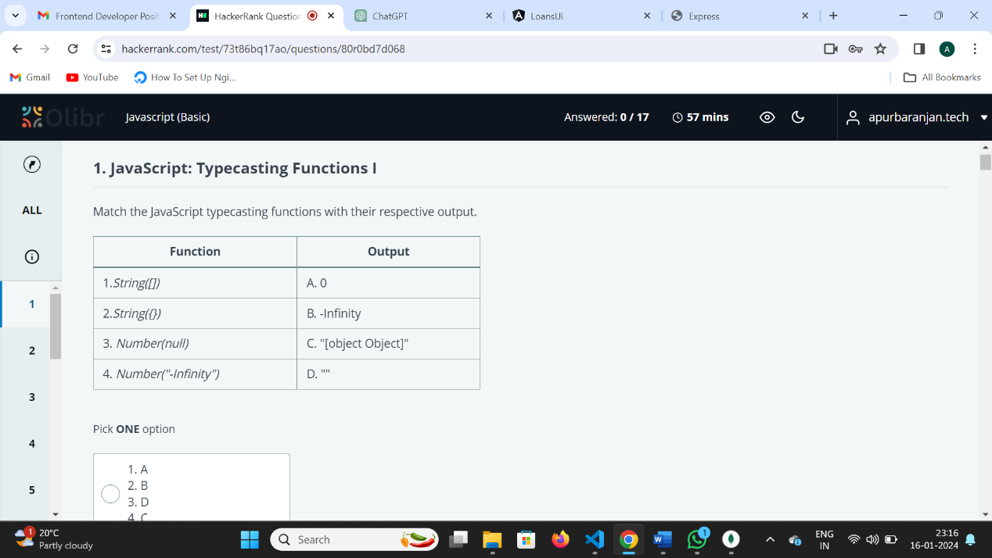

Certainly, let's break it down further:

1. **String([])** - D. "":
   * For arrays, the toString() method is defined to join all the elements of the array into a string, separated by commas.

In the case of an empty array [], there are no elements to join, so the result of toString() is an empty string ("").

1. **String({})** - C. "[object Object]":
   * Similarly, when you try to convert an empty object (**{}**) to a string using **String({})**, JavaScript calls the **toString()** method on the object. The default **toString()** method for objects returns **"[object Object]"**.
2. **Number(null)** - A. 0:
   * The **Number(null)** function explicitly converts the value **null** to a number. In JavaScript, when you convert **null** to a number, it results in **0**.
3. **Number("-Infinity")** - B. -Infinity:
   * The **Number("-Infinity")** function converts the string **"-Infinity"** to a number. This is a special case where the string represents negative infinity, and the result is **-Infinity**.

So, the key takeaway is that typecasting in JavaScript involves converting values from one type to another. In these examples, we used **String()** to convert arrays and objects to strings, and **Number()** to convert null and a string representing negative infinity to numbers. The results are based on the default behaviors specified by JavaScript for these type conversions.

2. function multiply(a) {

return function(b) {

return function(c) {

return a * b * c;

};

};

}

const double = multiply(2);

const triple = multiply(3);

const result = triple(double(4)(5))(1);

console.log(result);//120

3. 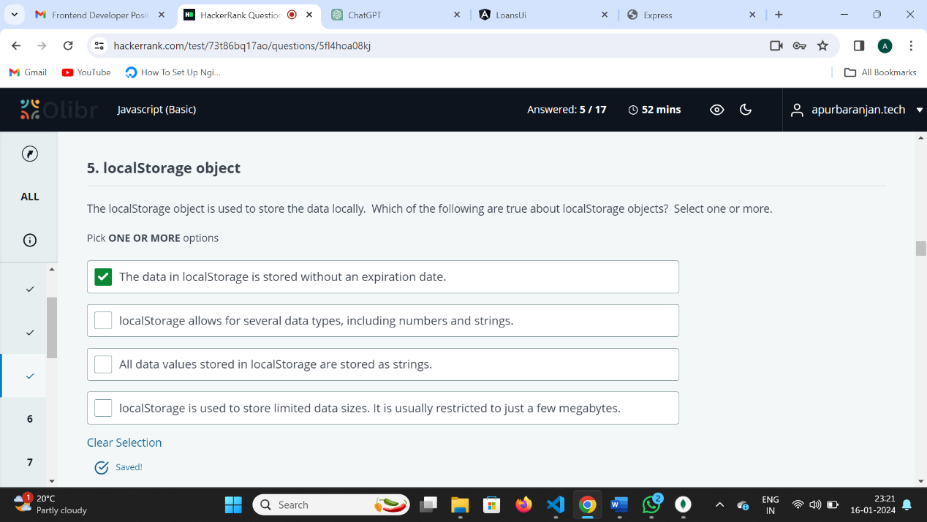

All are true

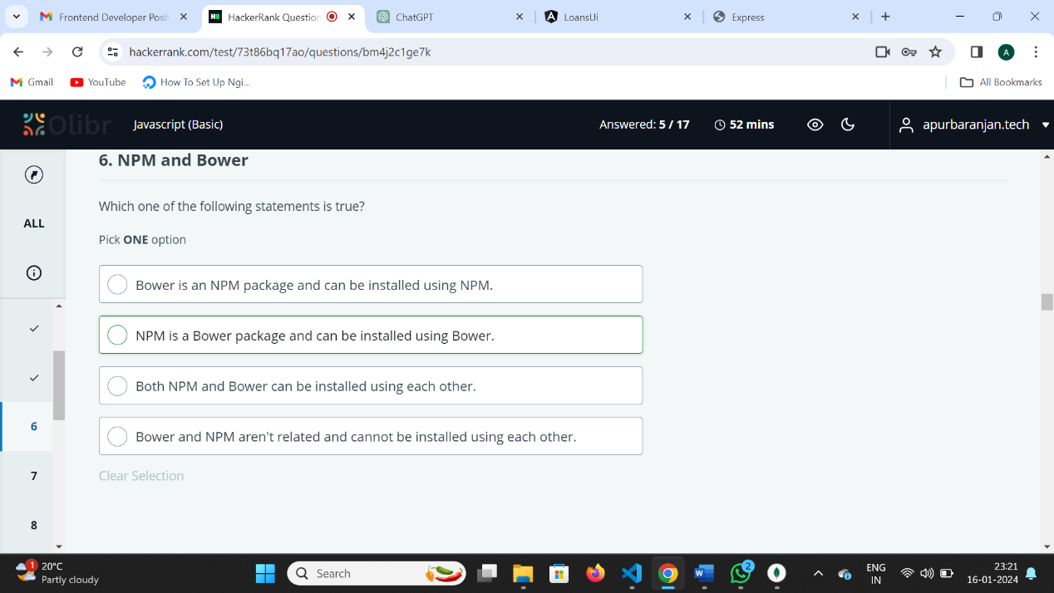

Certainly! NPM (Node Package Manager) and Bower are both package managers, but they serve different purposes and are not interchangeable with each other.

1. **NPM (Node Package Manager):**
   * NPM is primarily used for managing JavaScript packages and dependencies for Node.js applications.
   * It is the default package manager for Node.js and is commonly used for server-side development.
   * NPM installs packages globally or locally, depending on the specified flags, and it manages dependencies in a **node_modules** directory.
2. **Bower:**
   * Bower, on the other hand, is a package manager specifically designed for front-end development.
   * It is used to manage front-end libraries, frameworks, and dependencies such as jQuery, Bootstrap, etc.
   * Bower installs packages locally in a **bower_components** directory within your project.

Now, to address the options:

* **Bower is an NPM package and can be installed using NPM.**
  + This statement is incorrect. Bower and NPM have separate ecosystems, and Bower packages are not typically installed using NPM.
* **NPM is a Bower package and can be installed using Bower.**
  + This statement is incorrect. NPM packages are not meant to be installed using Bower, as they serve different purposes.
* **Both NPM and Bower can be installed using each other.**
  + This statement is incorrect. NPM and Bower are independent package managers and cannot be used interchangeably.
* **Bower and NPM aren't related and cannot be installed using each other.**
  + This statement is correct. Bower and NPM have distinct purposes and do not have interoperability for installing each other's packages.

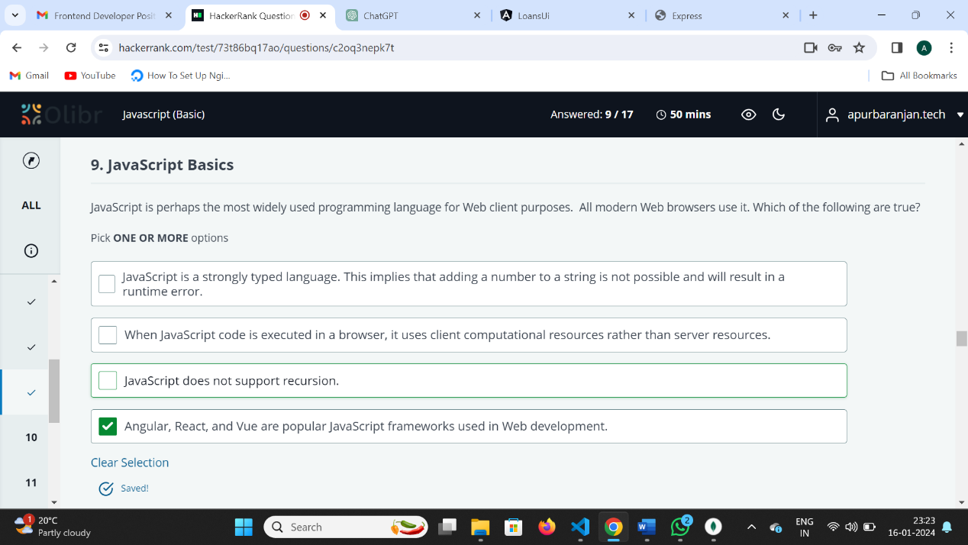

1. **JavaScript is a strongly typed language. This implies that adding a number to a string is not possible and will result in a runtime error.**
   * This statement is incorrect. JavaScript is actually a loosely typed language, which means that you can perform operations like adding a number to a string without resulting in a runtime error. The language will attempt to perform type coercion to accommodate the operation.
2. **When JavaScript code is executed in a browser, it uses client computational resources rather than server resources.**
   * This statement is correct. JavaScript is a client-side scripting language, and when executed in a browser, it runs on the client's machine, utilizing the client's computational resources.
3. **JavaScript does not support recursion.**
   * This statement is incorrect. JavaScript does support recursion, which is the ability of a function to call itself. Recursion is a programming technique that can be used in JavaScript for tasks where a function needs to repeat a certain operation.
4. **Angular, React, and Vue are popular JavaScript frameworks used in Web development.**
   * This statement is correct. Angular, React, and Vue are indeed popular JavaScript frameworks used for building user interfaces in web development. They help developers create dynamic and interactive web applications.

Top of Form

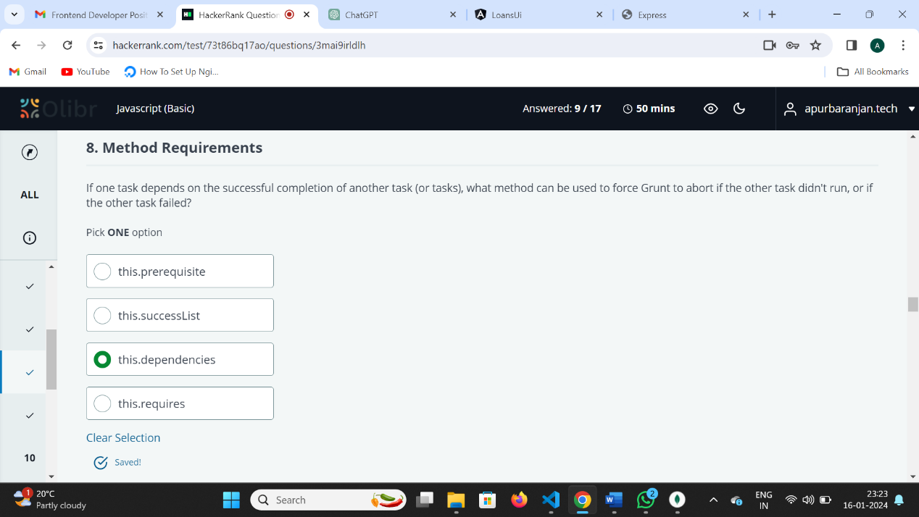

The correct option is:

⚫ **this.requires**

In Grunt, the **this.requires** method is used to specify that a task requires the successful completion of another task before it can run. If the prerequisite task fails, Grunt will automatically abort the dependent task and won't proceed with its execution.

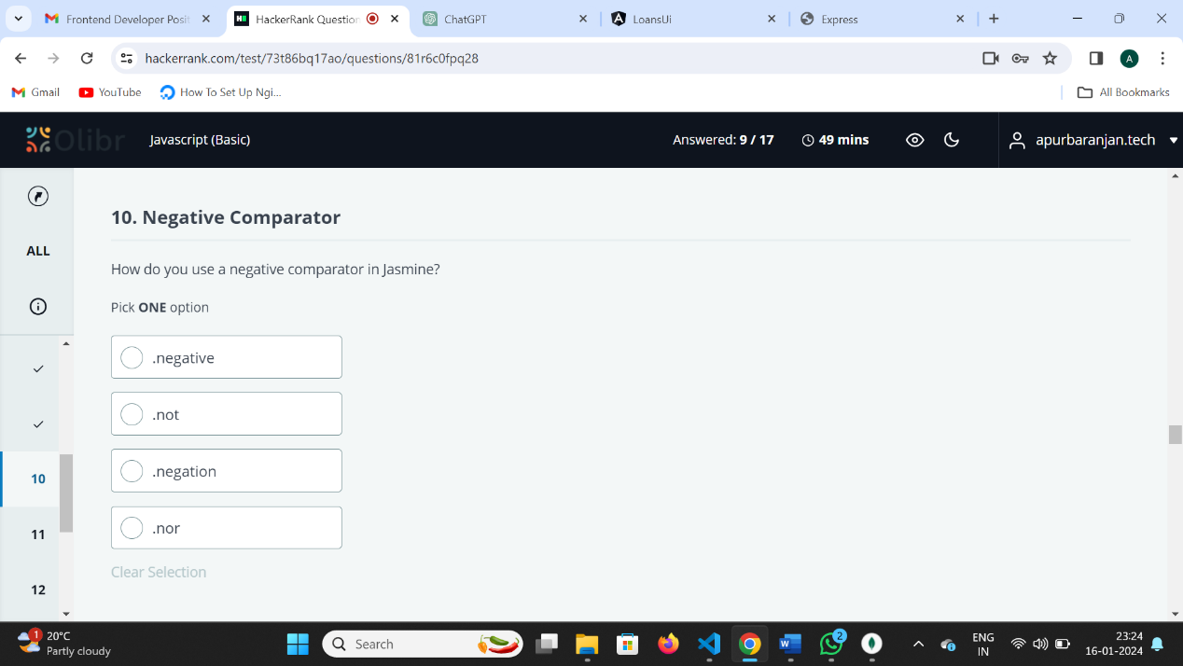

The correct option is:

.not

In Jasmine, you can use the **.not** property to create negative assertions. For example:

expect(someValue).not.toBe(someOtherValue);

This asserts that **someValue** is not equal to **someOtherValue**. The **.not** property is used to negate the expectation.

Q. const str = "1";

const obj = new String("1");

console.log(obj == "1"); //true

console.log(obj === str);//false

console.log(obj == str);//true

1. **console.log(obj == "1");**
   * This statement checks if the value of **obj** is equal to the string "1" using loose equality (**==**). In this case, it will return **true** because loose equality allows type coercion, and the value of **obj** is coerced to a string before comparison.
2. **console.log(obj === str);**
   * This statement checks if the value of **obj** is strictly equal to the value of **str** using strict equality (**===**). Strict equality does not perform type coercion, so this will return **false** because **obj** is an object (created using **new String()**) and **str** is a primitive string.
3. **console.log(obj == str);**
   * This statement checks if the value of **obj** is equal to the value of **str** using loose equality (**==**). Similar to the first case, it will return **true** because loose equality allows type coercion, and the value of **obj** is coerced to a string before comparison.

So, the output of the code will be:

javascript

true false true

In summary, when using loose equality (**==**), JavaScript performs type coercion, and in the case of comparing a string primitive with a String object, the object is coerced to a string for the purpose of the comparison. Strict equality (**===**) does not perform type coercion and checks both value and type.

Top of Form

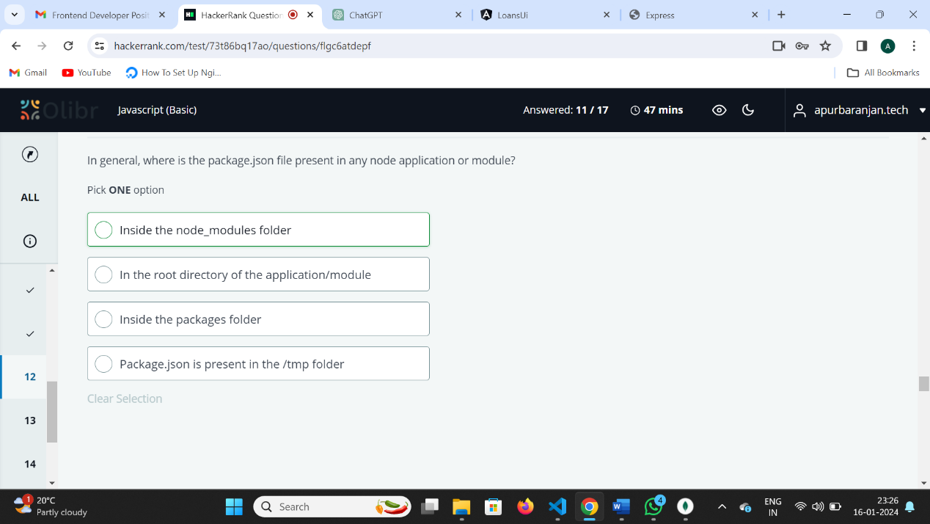

In general, the **package.json** file is present in the root directory of the Node.js application or module. It contains metadata about the project and is used to manage the project's dependencies, scripts, version information, and other configuration details. The **package.json** file is a crucial part of Node.js projects, and it is typically located in the project's main directory, not inside the **node_modules** folder or any other specific subdirectory.

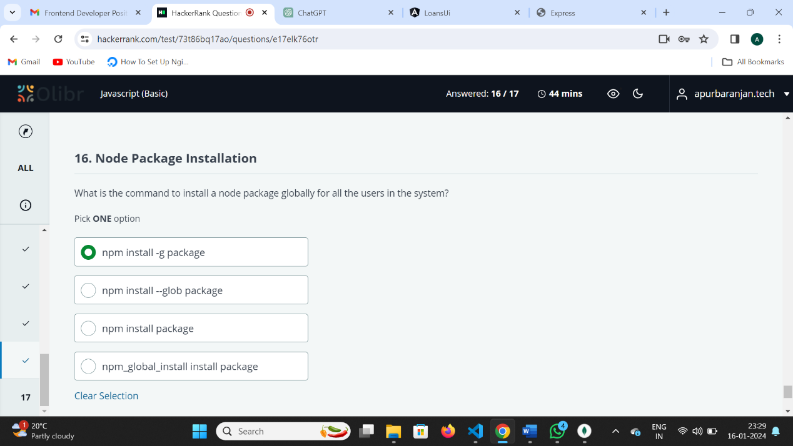

npm install -g package

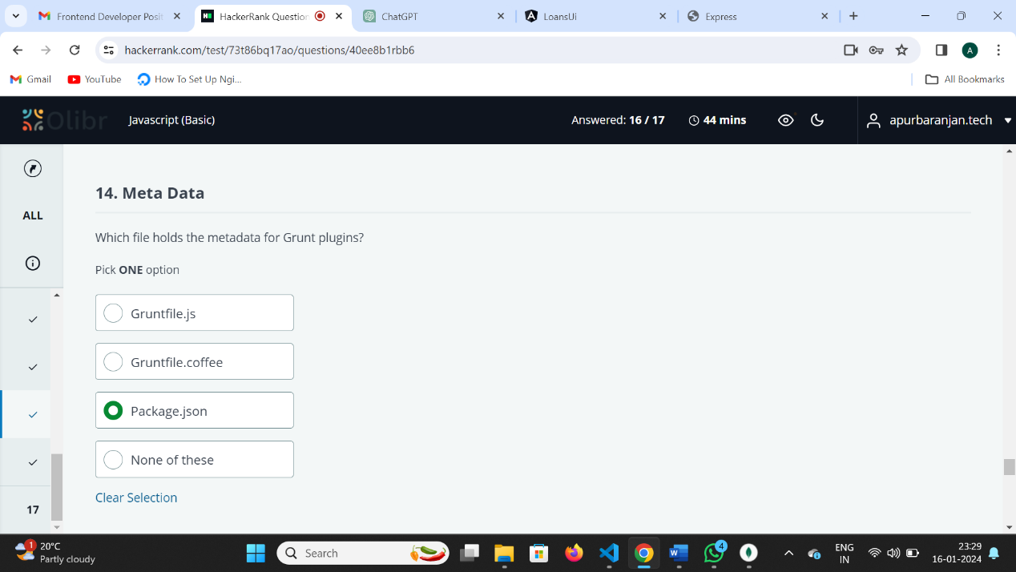

The metadata for Grunt plugins is typically specified in the **package.json** file of your Grunt project. This file includes information about the project, its dependencies, and configurations, including details about Grunt plugins used in the project. The plugin-related information is usually found in the **devDependencies** section of the **package.json** file.

q. in angular application in service we call API it will check that if data came then we load the component with data is not coming will not load component how can you do it by Resolve routing

Ans: In Angular, you can use a resolver to fetch data before the route is activated and the component is loaded. Resolvers are services that help you pre-fetch data and ensure that the required data is available before the route is activated. If the data is not available, the route activation is blocked, and the component is not loaded.

q. ng generate service auth

ng generate guard auth which is correct to create authentication in angular?

Ans:

Both **ng generate guard auth** and **ng generate service auth** commands are correct in different contexts. Let me clarify each one:

1. **ng generate guard auth:**
   * This command generates an Angular guard service named **auth.guard**.
   * Guards are typically used to control access to routes and can be used for implementing authentication checks. In the context of authentication, an auth guard can be used to protect certain routes and ensure that only authenticated users have access.
2. **CanActivate**: Determines if a user can access a route, often used for authentication checks before allowing access.
3. **CanActivateChild**: Similar to CanActivate, but specifically controls access to child routes, allowing for nested route protection.
4. **CanDeactivate**: Prevents users from leaving a route by prompting them if there are unsaved changes, ensuring they confirm navigation away.
5. **CanLoad**: Restricts the loading of lazy-loaded modules, useful for guarding against unauthorized access before a module is fetched.
6. **Resolve**: Used to fetch data before a route is activated, allowing components to receive pre-fetched data, implemented via a resolver service rather than a guard.
7. **ng generate service auth:**
   * This command generates an Angular service named **auth.service**.
   * Services are used for various purposes, and in the context of authentication, you might use a service to encapsulate authentication logic, handle token storage/retrieval, and interact with authentication APIs.

**Combining Guards and Services for Authentication:**

In many authentication implementations, you might use both guards and services. The guard controls access to routes, while the service handles the actual authentication logic, user session management, and communication with the server.

For a typical authentication setup, you might:

* Use **ng generate service auth** to create an authentication service.
* Implement methods in the service for login, logout, and checking authentication status.
* Use **ng generate guard auth** to create a guard that uses the authentication service to check whether the user is authenticated.

Q.

* **angular.json** – The file manages the workspace and project-specific defaults for every Angular build and development purpose. No matter how many npm packages the developers have installed in the workspace, they need to specify the list of packages to be used when they need them in your application in angular.json.
* In Angular projects, the main file that holds project configuration information and settings is typically the angular.json file. This file is located at the root of your Angular project.
* The angular.json file is an Angular CLI configuration file that defines various settings for your project, including:
* **package.json –** This [AngularJS framework](https://www.albiorixtech.com/blog/angularjs-frameworks/) file includes the project’s metadata and plays an essential role in managing the project’s dependencies, scripts, npm package versions and many more.
* The package.json file is a crucial part of any Node.js project, including Angular projects. It holds metadata about the project, such as its name, version, dependencies, and various other configurations. Here's a breakdown of its key elements in an Angular project:
* **package-lock.json –** This file includes all the information related to npm packages installed in the npm_modules folder. Some info like package version, hash to verify the package integrity and list of its dependencies are included in the file.

Here's a breakdown of the differences between angular.json, package.json, and package-lock.json files in an Angular project:

angular.json:

Purpose: Configuration file specific to Angular projects managed by the Angular CLI.

Contents: Contains project-specific configurations for build options, serve options, test options, and linting options.

Usage: Used by the Angular CLI to build, serve, test, and lint Angular applications.

Example: Configures settings such as project structure, assets, styles, scripts, and various build options.

package.json:

Purpose: Metadata file for the project, used by npm or yarn.

Contents: Contains metadata about the project, such as name, version, description, author, license, and project dependencies (both dependencies and devDependencies).

Usage: Used by package managers to install dependencies, run scripts, and manage project-related tasks.

Example: Defines project information, dependencies, devDependencies, scripts for build, test, serve, etc.

package-lock.json:

Purpose: Lock file automatically generated by npm to lock down the exact versions of dependencies installed in the project.

Contents: Contains a complete dependency tree, including all nested dependencies and their versions, ensuring consistent installations across different environments.

Usage: Ensures that every time npm install is run, the exact same versions of dependencies are installed, preventing unexpected or unintentional upgrades.

Example: Locks down the exact version of each package and its dependencies, ensuring reproducible builds and consistent project environments.

In summary, angular.json is specific to Angular projects and contains project configuration settings for the Angular CLI. package.json is a metadata file for the entire project, including project information and dependencies. package-lock.json is a lock file generated by npm to lock down exact dependency versions and ensure consistent installations across different environments. Each file serves a distinct purpose in managing and configuring Angular projects and their dependencies.

* **tsconfig.json –** TypeScript is a language developers typically use to develop Angular apps. This file specifies root files and compiler options required to compile our web application development process.
* **== (Loose Equality)**: Compares values with type conversion. Example: 2 == "2" is true because "2" is converted to 2.
* **=== (Strict Equality)**: Compares both value and type without conversion. Example: 2 === "2" is false because the types differ (number vs. string).

Q.   
In JavaScript, when you compare two objects using the equality operator (**==**), it checks whether the references to the objects are the same, not their content. Therefore, even if the content of objects **a** and **b** is the same, the comparison **a == b** will evaluate to **false** because they are distinct objects in memory.

const a = { prop: 'value' };

const b = { prop: 'value' };

console.log(a == b); // Outputs: false

Q. Yes, the output will be **false**. When you use the strict equality operator (**===**) in JavaScript to compare two objects, it checks whether they refer to the exact same object in memory. In your example:

const a = { prop: 'value' };

const b = { prop: 'value' };

console.log(a === b); // Outputs: false

Q.

const a = { prop: 'value' };

const b = { prop: 'value' };

console.log(JSON.stringify(a) == JSON.stringify(b)); // Outputs: true

Q. const a = { prop: 'value' };

const b = { prop: 'value' };

console.log(JSON.stringify(a) === JSON.stringify(b)); // Outputs: true

Q.Bootstraping: <https://www.youtube.com/watch?v=zVX1vgsXelo>

Q. APP_INITIALIZER is a Dependency Injection token that can use to load configuration information before the app starts. A DI token that you can use to provide one or more initialization functions

APP_INITIALIZER is a tool in Angular that lets you run some code **before the app fully starts up**. It’s helpful when you need to get certain information ready (like app settings, user preferences, or remote data) before the user starts interacting with the app.

q. In Angular, the **trackBy** function is used with the **ngFor** directive to improve the performance of rendering lists by providing a hint to Angular about how to track changes in the items of the list.

<https://www.youtube.com/watch?v=wUq7yQVjmFw>

The basic syntax of **ngFor** with **trackBy** looks like this:

<div *ngFor="let item of items; trackBy: trackByUserId ">

<!-- content of the item -->

</div>

// app.component.ts

import { Component } from '@angular/core';

@Component({

selector: 'app-root',

template: `

<div *ngFor="let user of users; trackBy: trackByUserId">

{{ user.id }} - {{ user.name }}

</div>

`,

})

export class AppComponent {

users = [

{ id: 1, name: 'John' },

{ id: 2, name: 'Jane' },

{ id: 3, name: 'Doe' },

];

trackByUserId(index: number, user: any): number {

return user.id; // Use a unique identifier, such as the user's ID

}

}

Here, trackByUserId is a method in your component that takes the index and the item and returns a unique identifier for each item. This helps Angular identify which items have changed and need to be updated in the DOM.

Q. how do you perform error handling in observable

Handling errors in observables is an important aspect of writing robust and reliable code. In Angular, which uses RxJS for handling observables, you can handle errors using the catchError operator or the subscribe method with an error callback. Here are two common approaches:

Using catchError Operator:

The catchError operator allows you to catch errors emitted by an observable and handle them appropriately. It's often used in conjunction with the pipe operator.

import { catchError } from 'rxjs/operators';

import { throwError, Observable } from 'rxjs';

// Example of using catchError with HTTP request

getData(): Observable<any> {

return this.http.get<any>('api/data').pipe(

catchError((error) => {

// Handle the error here (log, show a message, etc.)

console.error('Error occurred:', error);

// Rethrow the error or return a new observable/error object

return throwError('Something went wrong. Please try again later.');

})

);

}

Another approach is to handle errors within the subscribe method by providing an error callback.

getData(): void {

this.http.get('api/data').subscribe(

(data) => {

// Handle successful data

console.log('Data received:', data);

},

(error) => {

// Handle the error here (log, show a message, etc.)

console.error('Error occurred:', error);

}

);

}

Error handling in both Observables and Promises in JavaScript involves using the **catch** (for Promises) or **catchError** (for Observables) operators. These operators allow you to handle errors and define the behavior when an error occurs.

In Promises, you use the **.catch()** method to handle errors:

const myPromise = new Promise((resolve, reject) => {

// Some asynchronous operation that may fail

const success = true;

if (success) {

resolve('Operation succeeded');

} else {

reject('Operation failed');

}

});

myPromise

.then(result => {

console.log(result);

})

.catch(error => {

console.error('Error:', error);

});

q. <button [disabled]="userLogin.invalid" class="form-button">Login</button>

How to apply css on disable property?

Ans: button:disabled{

  cursor: not-allowed;

}

Q. In Angular, interceptors are a powerful feature that allows you to intercept HTTP requests or responses and perform operations before they are sent to the server or after they are received from the server. Interceptors are commonly used for tasks such as authentication, logging, error handling, modifying headers, or adding additional information to requests.

To create an interceptor in Angular, you need to implement the HttpInterceptor interface. The HttpInterceptor interface has two methods: intercept for handling requests and intercept for handling responses.

Here's a basic example of creating an interceptor:

Q.

const arr = [1,2,4]; console.log(typeof arr); how to print arr is array?

const arr = [1, 2, 4];

console.log(Array.isArray(arr)); // Output: true

Q. **Rest Parameter:** It's like a magic bag that collects all the extra things you give it and puts them neatly into a box, so you can use them all together.

function sum(a,b,...rest){//rest should in last

console.log(rest);

}

sum(1,2,4,5,6);

The function takes two parameters, a and b, and a rest parameter ...rest which collects any additional arguments into an array.

**Spread Operator**: It's like a magic wand that takes things from a box and spreads them out, so you can use them one by one.

console.log(Math.min(1,4,3,7));//1

const arr1 = [1,4,3,7];

console.log(Math.min(arr1));//NaN

//In array Math.Min will not work But we can do using spread

console.log(Math.min(...arr1));//1

<https://youtu.be/ROqYo6GW0g4?si=6wecoByG7pgSbxt4>

Q.What is starting point of an angular app?

it's also important to mention that while index.html is the starting point for loading the application, main.ts is where the Angular application is initialized and bootstrapped. This demonstrates a deeper understanding of the Angular application's startup process.

index.html:

* index.html is indeed the main HTML file of an Angular application.
* It serves as the entry point for your Angular application in the browser.
* Inside index.html, there's typically a placeholder element, often <app-root>, where the Angular application will be bootstrapped.

main.ts:

* main.ts is the main TypeScript file of an Angular application.
* It's where the Angular application is initialized and bootstrapped.
* In main.ts, you import the AppModule (or the root module of your application) and pass it to platformBrowserDynamic().bootstrapModule() to bootstrap the application.

So, in summary, index.html is the starting point for loading your Angular application in the browser, and main.ts is where the Angular application is initialized and bootstrapped. They both play essential roles in starting up an Angular application.

Q. In Angular, a "singleton service" means that there is only one instance of the service created, and that same instance is used everywhere in the application that needs it.

@Injectable({

providedIn: 'root',//Declare once used everywhere

})

Yes, in Angular, you can create multiple instances of a service by providing it at different levels of the application's injector hierarchy. By default, services provided in Angular are singletons, meaning there's only one instance of the service created and shared across the entire application. However, you can configure Angular to create multiple instances of a service by providing it at a different injector scope.

providers: [

MyService // Provides MyService at the module level

]

And here's an example of providing a service at the component level:

@Component({

selector: 'app-my-component',

templateUrl: './my-component.component.html',

styleUrls: ['./my-component.component.css'],

providers: [MyService] // Provides MyService at the component level

})

**DECORTOR:**

In Angular, a **decorator** is a function that adds extra information or behavior to something. It's like a special label that tells Angular what a piece of code should do.

**Simple Types of Decorators**

1. **Class Decorators**
   * Used to define what a class does, like a component or a service.
   * **Example:**

@Component({

selector: 'app-hello',

template: '<h1>Hello World!</h1>'

})

export class HelloComponent {}

* + Here, @Component tells Angular that HelloComponent is a component.

1. **Property Decorators**
   * Used for properties to tell Angular how to use them.
   * **Example:**

@Input() name: string;

* + @Input lets a property receive a value from a parent component.

**3.Method Decorators**

* + Used to add behavior to methods, such as reacting to events.
  + **Example:**

@HostListener('click')

handleClick() {

console.log('Clicked!');

}

* + @HostListener makes the method run when an event happens (like a click).

1. **Parameter Decorators**
   * Used to give extra information about parameters in a constructor.
   * **Example:**

constructor(@Inject(SomeService) service) {}

* + @Inject helps Angular know what service to provide.

**In Short:**

* **Class Decorators:** Label a class (e.g., @Component).
* **Property Decorators:** Label a property (e.g., @Input).
* **Method Decorators:** Label a method (e.g., @HostListener).
* **Parameter Decorators:** Label a parameter (e.g., @Inject).

Decorators tell Angular what each part of the code is supposed to do!

**OOPs:**

Object-Oriented Programming (OOP) in TypeScript revolves around the concepts of classes, objects, inheritance, encapsulation, and polymorphism. TypeScript is a superset of JavaScript, so it supports all the OOP features provided by JavaScript along with some additional features like type annotations, interfaces, abstract classes, and access modifiers. Let's delve into these concepts in detail:

**Classes and Objects:**

Classes: A class is a blueprint for creating objects. It encapsulates data for the object and operations that can be performed on the data.

Objects: Objects are instances of classes. They contain properties (data) and methods (functions) defined in the class blueprint.

class Person {

name: string;

age: number;

constructor(name: string, age: number) {

this.name = name;

this.age = age;

}

greet() {

console.log(`Hello, my name is ${this.name} and I am ${this.age} years old.`);

}

}

let person1 = new Person('Alice', 30);

person1.greet(); // Output: Hello, my name is Alice and I am 30 years old.

The constructor is a special method within a TypeScript class. It is automatically called when a new instance of the class is created using the new keyword. The constructor method is responsible for initializing the newly created object's properties.

In this specific Person class:

The constructor method takes two parameters: name (a string) and age (a number).

Inside the constructor, this.name = name; assigns the value of the name parameter to the name property of the newly created Person object.

Similarly, this.age = age; assigns the value of the age parameter to the age property of the newly created Person object.

So, when you create a new Person object like let person1 = new Person('Alice', 30);, the constructor is automatically invoked with the provided arguments 'Alice' and 30, setting the name and age properties of the person1 object accordingly.

So, the **constructor** essentially initializes the properties of the object with the values passed during object creation. It's a fundamental part of creating objects in classes in TypeScript.

**Inheritance:**

inheritance allows a child class to inherit properties and methods from a parent class. This means the child class can reuse code from the parent class and also add its own unique features. However, the parent class cannot directly access properties or methods of the child class. The subclass can extend the superclass, inheriting its members and adding its own members as needed.

Syntax:

class Superclass {

// Properties and methods

}

class Subclass extends Superclass {

// Additional properties and methods

}

class Animal {

name: string;

constructor(name: string) {

this.name = name;

}

makeSound() {

console.log("Some generic sound");

}

}

class Dog extends Animal {

breed: string;

constructor(name: string, breed: string) {

super(name); // Call the constructor of the superclass

this.breed = breed;

}

makeSound() {

console.log("Woof!");

}

fetch() {

        console.log(`${this.name} is fetching...`); // Use this.name to access the dog's name

    }

}

// Creating instances of the classes

let animal = new Animal("Generic Animal");

let dog = new Dog("Buddy", "Labrador");

// Using methods

animal.makeSound(); // Outputs: Some generic sound

dog.makeSound(); // Outputs: Woof!

dog.fetch(); // Outputs: Buddy is Fetching...

In this example:

Animal is the superclass, and Dog is the subclass.

Dog extends Animal using the extends keyword.

The super keyword is used inside the constructor of Dog to call the constructor of Animal and initialize the name property inherited from Animal.

Dog overrides the makeSound method of Animal with its own implementation. This is called method overriding.

Dog has its own method fetch, which is not present in Animal.

Through inheritance, Dog inherits the name property and the makeSound method from Animal. It also adds its own breed property and fetch method.

Inheritance in TypeScript follows single inheritance, meaning a subclass can only inherit from a single superclass. However, TypeScript supports mixins, interfaces, and other patterns to achieve composition and multiple inheritance-like behavior when necessary.

**Method Overloading:**

Method overloading refers to the ability to define multiple methods with the same name but with different parameters within the same class. The compiler determines which method to call based on the number and types of arguments provided during the method invocation.

class Calculator {

add(x: number, y: number): number;

add(x: number, y: number, z: number): number;

add(x: number, y: number, z?: number): number {

if (z !== undefined) {

return x + y + z;

} else {

return x + y;

}

}

}

let calc = new Calculator();

console.log(calc.add(2, 3)); // Outputs: 5

console.log(calc.add(2, 3, 4)); // Outputs: 9

**Method Overriding:**

Method overriding occurs when a subclass provides a specific implementation for a method that is already defined in its superclass. The method signature (name and parameters) in the subclass must match the method signature in the superclass.

class Animal {

makeSound() {

console.log("Some generic sound");

}

}

class Dog extends Animal {

makeSound() {

console.log("Woof!");

}

}

let animal: Animal = new Animal();

let dog: Animal = new Dog();

animal.makeSound(); // Outputs: Some generic sound

dog.makeSound(); // Outputs: Woof!

Q.In a single class can we define multiple same method name in oops?

Ans: while technically you can define multiple methods with the same name in TypeScript, only the last one will be retained, and it's generally not considered good practice to do so because it can lead to confusion and unexpected behavior.

class Example {

method(): void {

console.log("First method");

}

method(): void {

console.log("Second method");

}

}

const example = new Example();

example.method(); // Outputs: "Second method"

**Encapsulation:**

It’s a process of providing security to most important component of object.It can be achieving by preventing direct access and providing control access.Direct access can be prevented by using private and access specifiers ,control access can be given by using getter and setter method.

Access Modifier:Public,Private ,Default and protected

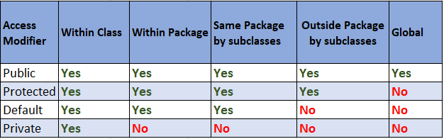

class Employee {

public name: string; // Public property

private salary: number; // Private property

protected id: number; // Protected property

constructor(name: string, salary: number, id: number) {

this.name = name;

this.salary = salary;

this.id = id;

}

public displayEmployee(): void {

console.log(`Name: ${this.name}, Salary: ${this.salary}, ID: ${this.id}`);

}

}

class Manager extends Employee {

constructor(name: string, salary: number, id: number) {

super(name, salary, id);

}

public displayManager(): void {

// Can access name and id (public and protected) but not salary (private)

console.log(`Manager: ${this.name}, ID: ${this.id}`);

}

}

let employee = new Employee("John", 50000, 101);

console.log(`Employee Name: ${employee.name}`); // Accessible

// console.log(`Employee Salary: ${employee.salary}`); // Error: Property 'salary' is private

// console.log(`Employee ID: ${employee.id}`); // Error: Property 'id' is protected

employee.displayEmployee(); // Outputs: Name: John, Salary: 50000, ID: 101

let manager = new Manager("Alice", 80000, 201);

console.log(`Manager Name: ${manager.name}`); // Accessible

// console.log(`Manager Salary: ${manager.salary}`); // Error: Property 'salary' is private

// console.log(`Manager ID: ${manager.id}`); // Error: Property 'id' is protected

manager.displayManager(); // Outputs: Manager: Alice, ID: 201

In this example:

Employee class has three properties: name (public), salary (private), and id (protected).

Manager class extends Employee, so it inherits the name and id properties. It cannot directly access the salary property.

Outside the Employee class, name can be accessed directly, salary cannot be accessed (private), and id cannot be accessed directly (protected).

Both Employee and Manager classes have a method to display employee/manager details, which can access the properties of the respective class.

USING getter and setter:

class Employee {

private _name: string; // Private property

private _salary: number; // Private property

protected _id: number; // Protected property

constructor(name: string, salary: number, id: number) {

this._name = name;

this._salary = salary;

this._id = id;

}

// Getter for name

public get name(): string {

return this._name;

}

// Setter for name

public set name(value: string) {

this._name = value;

}

// Getter for salary

public get salary(): number {

return this._salary;

}

// Setter for salary

public set salary(value: number) {

this._salary = value;

}

// Method to display employee details

public displayEmployee(): void {

console.log(`Name: ${this._name}, Salary: ${this._salary}, ID: ${this._id}`);

}

}

class Manager extends Employee {

constructor(name: string, salary: number, id: number) {

super(name, salary, id);

}

// Method to display manager details

public displayManager(): void {

// Can access name and id (public and protected) but not salary (private)

console.log(`Manager: ${this.name}, Salary: ${this.salary}, ID: ${this._id}`);

}

}

let employee = new Employee("John", 50000, 101);

console.log(`Employee Name: ${employee.name}`); // Accessible via getter

employee.name = "Jane"; // Accessible via setter

console.log(`Updated Employee Name: ${employee.name}`);

employee.displayEmployee(); // Outputs: Name: Jane, Salary: 50000, ID: 101

let manager = new Manager("Alice", 80000, 201);

console.log(`Manager Name: ${manager.name}`); // Accessible via getter

console.log(`Manager Salary: ${manager.salary}`); // Accessible via getter

manager.displayManager(); // Outputs: Manager: Alice, Salary: 80000, ID: 201

Static:

In TypeScript, a static member (method or variable) belongs to the class itself, rather than to instances of the class. This means you can access static members directly through the class name without needing to create an instance of the class.

When you declare a function (or method) as **static** in TypeScript (or JavaScript), you do not need to create an instance (object) of the class to call that function. You can call the static method directly using the class name.

class MyClass {

static myStaticMethod() {

console.log('This is a static method');

}

}

// Calling the static method directly through the class name

MyClass.myStaticMethod(); // Outputs: This is a static method

class MyClass {

static myStaticProperty: number = 42;

// Static method accessing static property

static printStaticProperty() {

console.log(MyClass.myStaticProperty);

}

}

console.log(MyClass.myStaticProperty); // Accessing static property

MyClass.printStaticProperty(); // Accessing static method

**Polymorphism:** it means many form. Ability of an object behave differently. where different objects can do similar actions but in their unique ways. Imagine you have a group of superhero animals—dogs, cats, and birds. They all respond to a command like "save the day," but each one does it differently based on its own abilities. This is like polymorphism.

2 types of polymorphism:

1.compile type:

Method Overloading: Method overloading allows defining multiple methods with the same name but with different parameter types or a different number of parameters. The compiler decides which method to call based on the arguments provided during compile time.

class Calculator {

add(x: number, y: number): number {

return x + y;

}

add(x: string, y: string): string {

return x + y;

}

}

const calc = new Calculator();

console.log(calc.add(5, 3)); // Compile-time: Calls add(x: number, y: number)

console.log(calc.add("Hello ", "world")); // Compile-time: Calls add(x: string, y: string)

2.run type:

Method Overriding: Method overriding allows a subclass to provide a specific implementation of a method that is already defined in its superclass. The compiler determines which method to call based on the reference type during compile time.

class Animal {

speak(): string {

return "Animal makes a sound";

}

}

class Dog extends Animal {

speak(): string {

return "Dog barks";

}

}

const animal: Animal = new Dog();

console.log(animal.speak()); // Compile-time: Calls Dog's speak method

**Abstraction:** **Abstraction is a key concept in object-oriented programming (OOP) that involves simplifying complex systems by focusing on essential characteristics while hiding unnecessary details. It provides a way to create models of real-world systems in software development by representing only the relevant aspects and hiding the implementation details.**

**1. Abstract Classes:**

TypeScript provides abstract classes, which are classes that cannot be instantiated directly. They are meant to serve as blueprints for other classes and may contain abstract methods, which are methods without a body. Subclasses must implement these abstract methods

abstract class Vehicle {

abstract start(): void; // Abstract method: Needs to be implemented by subclasses

abstract stop(): void; // Abstract method: Needs to be implemented by subclasses

move(): void {

console.log("Vehicle is moving");

}

}

class Car extends Vehicle {

start(): void {

console.log("Car is starting");

}

stop(): void {

console.log("Car is stopping");

}

}

class Truck extends Vehicle {

start(): void {

console.log("Truck is starting");

}

stop(): void {

console.log("Truck is stopping");

}

}

let car: Vehicle = new Car();

car.start(); // Output: Car is starting

car.move(); // Output: Vehicle is moving

car.stop(); // Output: Car is stopping

let truck: Vehicle = new Truck();

truck.start(); // Output: Truck is starting

truck.move(); // Output: Vehicle is moving

truck.stop(); // Output: Truck is stopping

Interfaces:

An interface is a contract that defines a set of methods or properties that a class must implement. It defines the structure and capabilities that a class should have without specifying how they should be implemented. Interfaces promote loose coupling by allowing classes to interact based on their common interface rather than their specific implementations.

HTML Entity:

<https://symbl.cc/en/html-entities/>

HTML entities are codes used to represent special characters, symbols, and reserved characters in HTML. They begin with an ampersand (&) and end with a semicolon (;). There are two types:

Named Entities: Represented by a name, such as &lt; for "<" (less-than symbol) and &copy; for "©" (copyright symbol).

Numeric Entities: Represented by a numerical code, either in decimal (e.g., &#60;) or hexadecimal (e.g., &#x3C;) format, corresponding to the character's Unicode code point.

HTML entities ensure correct display of characters, especially those with special meaning in HTML or those not easily typed on a keyboard. They are used to avoid interpretation issues by web browsers.

&lt; represents the less-than symbol ("<").

&gt; represents the greater-than symbol (">").

&amp; represents the ampersand symbol ("&").

&quot; represents the quotation mark (").

&copy; represents the copyright symbol ("©")

Q>We provided some simple Angular template code. Modify the app-dynamic-form template so that when you change one of the properties in the person object in the form, it is reflected in the json object below it. Your final output should look [something like this](https://s3.amazonaws.com/coderbytestaticimages/editor/challenges/angular_correct.png).

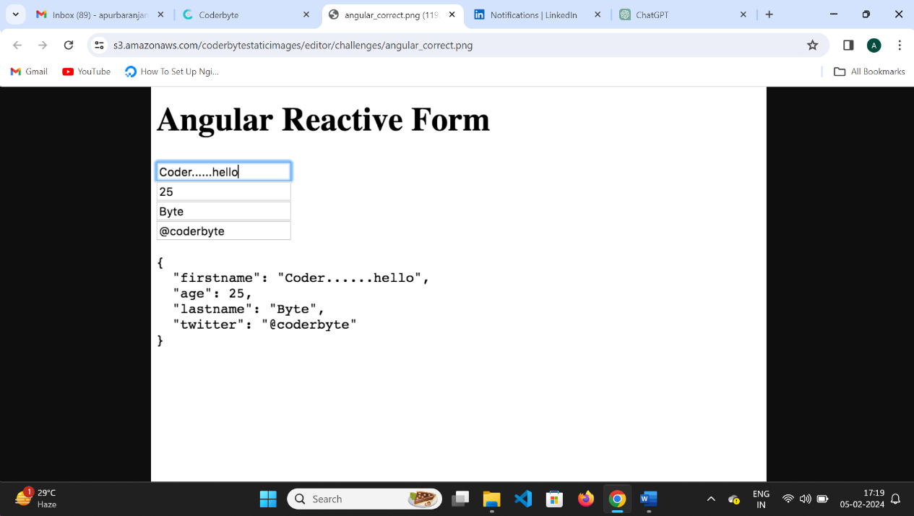  
  
You are free to add classes and styles, but make sure you leave the element ID's as they are. Submit your code once it is complete and our system will validate your output.

Solution:

import { Component, OnInit } from '@angular/core';

import { FormGroup, FormControl } from '@angular/forms';

@Component({

selector: 'app-area',

template: `

<form [formGroup]="form">

<label for="firstname">First Name:</label>

<input type="text" id="firstname" formControlName="firstname"><br>

<label for="lastname">Last Name:</label>

<input type="text" id="lastname" formControlName="lastname"><br>

<label for="age">Age:</label>

<input type="number" id="age" formControlName="age"><br>

<label for="twitter">Twitter:</label>

<input type="text" id="twitter" formControlName="twitter"><br>

</form>

<pre id="app-json-output">{{ form.value | json }}</pre>

`,

styles: []

})

export class MainAppComponent implements OnInit {

form: FormGroup;

person = {

firstname: 'Bubu',

age: 25,

lastname: 'Byte',

twitter: '@coderbyte'

};

ngOnInit() {

const formDataObj = {};

for (const prop of Object.keys(this.person)) {

formDataObj[prop] = new FormControl(this.person[prop]);

}

this.form = new FormGroup(formDataObj);

// Subscribe to form value changes and update person object accordingly

this.form.valueChanges.subscribe((value) => {

this.person = { ...this.person, ...value };

});

}

}

**Q. for...of loop:**

The for...of loop iterates over the values of an iterable object, such as arrays, strings, maps, sets, etc.

It provides a concise syntax for iterating over elements of an iterable.

It does not provide access to the index of the current element.

Example: const arr = [1, 2, 3];

for (const element of arr) {

console.log(element);//1 2 3

}

**for...in loop:**

The for...in loop iterates over the enumerable properties of an object.

It is used to iterate over the keys (property names) of an object.

It is not recommended to use for...in loop with arrays as it may iterate over non-index properties inherited from the prototype chain and doesn't guarantee the order of iteration.

Example:

const obj = { a: 1, b: 2, c: 3 };

for (const key in obj) {

console.log(key, obj[key]);// a 1 b 2 c 3

}

**forEach loop:**

The forEach method is a higher-order function available on arrays.

It iterates over each element of the array and executes a callback function for each element.

It provides access to both the element and its index.

It is more suitable for arrays when you want to perform an operation on each element.

Example:

const arr = [1, 2, 3];

arr.forEach((element, index) => {

console.log(element, index);//

1 0

2 1

3 2

});

**Q.How to handle error in observable:**

Use the catchError operator: This operator allows you to intercept errors emitted by an observable and handle them appropriately. You can provide a callback function to catchError to handle errors, log them, provide fallback values, or even throw new errors.

import { Injectable } from '@angular/core';

import { HttpClient } from '@angular/common/http';

import { Observable, throwError } from 'rxjs';

import { catchError } from 'rxjs/operators';

@Injectable({

providedIn: 'root'

})

export class DataService {

private apiUrl = 'https://api.example.com/data';

constructor(private http: HttpClient) { }

getData(): Observable<any> {

return this.http.get<any>(this.apiUrl).pipe(

catchError(error => {

console.error('An error occurred:', error);

// Return a new observable or throw an error

return throwError('Failed to fetch data');

})

);

}

}

b.Subscribe to the observable: When subscribing to an observable, you can specify a second argument to handle errors. This allows you to handle errors at the point of subscription, providing more granular control over error handling logic.

import { Component, OnInit } from '@angular/core';

import { DataService } from './data.service';

@Component({

selector: 'app-data',

templateUrl: './data.component.html',

styleUrls: ['./data.component.css']

})

export class DataComponent implements OnInit {

data: any;

error: string;

constructor(private dataService: DataService) { }

ngOnInit(): void {

this.fetchData();

}

fetchData(): void {

this.dataService.getData().subscribe(

response => {

this.data = response;

},

error => {

this.error = error;

}

);

}

}

Q.Change detection is not working?

If change detection doesn't work as expected in an Angular application, it can lead to issues such as stale data being displayed, incorrect view updates, or unexpected behavior. Here are some steps to troubleshoot and address change detection issues in Angular:

Check Component Bindings: Ensure that data bindings between components and templates are set up correctly. Double-check property bindings ([property]="value"), event bindings ((event)="handler()"), and two-way data bindings ([(ngModel)]="property").

Verify Change Detection Strategy: Check the change detection strategy used by the component. By default, Angular uses the ChangeDetectionStrategy.Default, but you may have explicitly set it to ChangeDetectionStrategy.OnPush. If set to OnPush, make sure that inputs to the component are immutable and that changes to them are detected properly.

Inspect Component Lifecycle: Use lifecycle hooks (ngOnInit, ngOnChanges, ngDoCheck, etc.) to inspect the component's lifecycle and verify that change detection is being triggered when expected. Check if change detection is being triggered by performing operations within these hooks and logging messages to the console.

Use ChangeDetectorRef: Inject ChangeDetectorRef into the component and manually trigger change detection using its detectChanges() method when needed. This can be useful when dealing with asynchronous operations or when you need to manually trigger change detection after certain actions.

Avoid Long-Running Operations in the Main Thread: Long-running operations in the main thread, such as complex calculations or heavy computations, can block the UI and affect change detection. Consider moving such operations to a separate thread or using setTimeout() to perform them asynchronously.

Use ngZone: If dealing with asynchronous operations, ensure that Angular's zone.js is properly patched. Use NgZone to execute code inside or outside Angular's zone as needed. This can help in ensuring that change detection is triggered appropriately after asynchronous operations complete.

Check for Memory Leaks: Memory leaks can also affect change detection. Make sure to unsubscribe from observables and clean up resources properly in ngOnDestroy lifecycle hook to prevent memory leaks that could interfere with change detection.

Enable Debugging: Enable Angular's debugging features, such as enableProdMode() and Angular DevTools, to inspect component trees, bindings, and change detection behavior. This can provide valuable insights into potential issues.

Review Browser Console: Check the browser console for any error messages, warnings, or log messages related to change detection. This can help identify specific issues that may be affecting change detection in your application.

By following these steps and carefully inspecting your application's components, templates, lifecycle hooks, and change detection strategies, you should be able to diagnose and resolve change detection issues in your Angular application.

In Angular, **change detection** is the process by which the framework keeps the app’s view in sync with its data. Whenever data in the app changes, Angular checks to see if the view needs to be updated to reflect those changes.

**Default Strategy (ChangeDetectionStrategy.Default)**:

* In the default mode, **any change in any part of the app** (like data updates, events, or async operations) will trigger a full change detection cycle.
* Angular starts from the root component and checks every component in the tree, updating all affected components, even if the change occurred far away in a different part of the app.
* This means all components are checked, even if their inputs haven’t changed.

**OnPush Strategy (ChangeDetectionStrategy.OnPush)**:

* When you set a component to use the OnPush strategy, Angular only checks that component (and its children) when:
  + Its **input properties** change (i.e., new data is passed from a parent component).
  + An **event is triggered inside that component** (like a button click).
* If changes happen outside the component or if a sibling component’s data changes, the OnPush component **will not be rechecked** unless it’s specifically marked for checking.

**How Zone.js Works**

* When an Angular application runs, Zone.js patches built-in JavaScript functions such as setTimeout, Promise, and XHR to track when these functions are called and when they complete.
* This tracking enables Zone.js to know when to trigger change detection automatically, updating the UI without the developer needing to manually invoke change detection.

Q.Router state and router link?

**RouterState** represents the state of the router at a specific point in time. It contains information about the current route, including the URL, route parameters, query parameters, and any additional data associated with the route.

You can access the current **RouterState** through the **Router** service provided by Angular. For example:

import { Router } from '@angular/router';

constructor(private router: Router) {}

ngOnInit() {

const routerState = this.router.routerState;

console.log(routerState);

}

RouterLink is a directive provided by Angular for creating links to different routes within the application. It allows you to navigate to different routes without reloading the entire page.

The RouterLink directive binds to a route path defined in the application's routing configuration. When clicked, it triggers the Angular router to navigate to the specified route.

You can use RouterLink in your templates to create navigation links. For example:

<a routerLink="/home">Home</a>

<a [routerLink]="['/products', productId]">Product Details</a>

In summary, **RouterState** represents the current state of the router, including the active route and its parameters, while **RouterLink** is used to create navigation links within the application without reloading the page. Understanding these concepts is essential for building and navigating Angular applications with a robust routing system.

Q.What happens if script tag will add inside template?

If you include a **<script>** tag within an Angular component's template, the content inside the **<script>** tag will be treated as plain text and displayed on the page. No JavaScript code within the **<script>** tag will be executed. Therefore, if you have the following template:

<app-my-component>

<h1>This is a component</h1>

<script>alert('This script will not be executed');</script>

</app-my-component>

Output:

This is a component

<script>alert('This script will not be executed');</script>

The JavaScript code inside the **<script>** tag will not be executed, and it will be displayed as plain text. This behavior is by design in Angular, as executing inline scripts within templates is not a recommended approach. Instead, logic and behavior should be implemented in the component class or through Angular's built-in features such as event bindings or directives.

What is ngrx and how does the control flow?

Answer: NgRx is a state management library for Angular applications based on the Redux pattern. It helps manage the state of an Angular application in a predictable and centralized way. The control flow in NgRx follows a unidirectional data flow pattern, where actions are dispatched to trigger state changes, reducers handle these actions to produce a new state, and components subscribe to the state to update the UI accordingly.

RxJS operators: forkJoin vs combineLatest

Answer:

forkJoin: Combines multiple observables into a single observable that emits an array of values when all the input observables have completed. It waits for all observables to emit a value and then emits an array containing the latest values from each observable.

combineLatest: Combines multiple observables into a single observable that emits an array of values whenever any of the input observables emits a new value. It emits an array containing the latest values from each observable whenever any observable emits a new value.

import { forkJoin, combineLatest, of } from 'rxjs';

// Example data observables

const observable1 = of('Hello');

const observable2 = of('World');

// Using forkJoin operator

const forkJoinExample = forkJoin([observable1, observable2]);

forkJoinExample.subscribe(([result1, result2]) => {

console.log('forkJoin result:', result1 + ' ' + result2);

});

// Using combineLatest operator

const combineLatestExample = combineLatest([observable1, observable2]);

combineLatestExample.subscribe(([result1, result2]) => {

console.log('combineLatest result:', result1 + ' ' + result2);

});

//output

forkJoin result: Hello World

combineLatest result: Hello World

SwitchMap vs MergeMap vs ConcatMap

<https://youtu.be/RFV_gEnqal8?si=DCPKuuYxoh_htOgI>

Answer:

switchMap: Maps each value from the source observable to a new observable, then cancels the previous inner observable if a new value arrives. Useful for scenarios like typeahead search where you want to ignore previous results and only consider the latest one.

mergeMap: Maps each value from the source observable to a new observable and emits the values from all inner observables concurrently. It does not order the emissions and can cause race conditions.

concatMap: Maps each value from the source observable to a new observable and emits the values from each inner observable sequentially, maintaining the order. It waits for each inner observable to complete before moving to the next one.

How can we attach more than one style file with a single component.html file?

Answer: You can include multiple stylesheets in an Angular component by using the styleUrls property in the component's decorator metadata. This property accepts an array of stylesheet URLs that will be applied to the component.

NgOnInit vs constructor

Answer: The constructor is a TypeScript class constructor function that is automatically called when an instance of the class is created. It is typically used for dependency injection and initialization of class properties.

ngOnInit is an Angular lifecycle hook that is called after the constructor and after Angular has initialized the component's data-bound properties. It is commonly used to perform component initialization tasks, such as fetching data from a service.

Angular Lifecycle hook invoked when the child component injected in HTML finishes loading?

Answer: There is no specific Angular lifecycle hook that is triggered when a child component injected in HTML finishes loading. However, you can use lifecycle hooks like ngAfterViewInit or ngAfterContentInit in the parent component to perform actions after its child components have been initialized and rendered.

**What are Subject? Behaviour Subject?**

Answer:

Subject: A Subject is a special type of Observable that allows values to be multicasted to multiple Observers. It acts as both an Observable and an Observer, so you can subscribe to it like any other Observable and also push new values to it using its next method.

BehaviorSubject: BehaviorSubject is a type of Subject that requires an initial value and emits the current value to new subscribers immediately upon subscription. It retains the last emitted value and replays it to new subscribers.

**Javascript method find vs some vs filter?**

Answer:

find: Returns the first element in an array that satisfies the provided testing function. If no element satisfies the testing function, undefined is returned.

some: Returns true if at least one element in the array satisfies the provided testing function; otherwise, returns false.

filter: Creates a new array with all elements that pass the test implemented by the provided testing function.

**Change Detection Strategies in Angular?**

Answer: Angular provides different change detection strategies to optimize performance:

Default: Checks all components and their child components on every change detection cycle.

OnPush: Only checks components and their child components if their input properties have changed, or if triggered manually. It ignores changes in other components.

Detached: Does not perform change detection for the component or its child components.

CheckOnce: Checks the component and its child components once and then disables further change detection.

**How to get data from an observable in component.ts file/directly in html file?**

Answer: In the component.ts file, you can subscribe to the observable and retrieve the data using the subscribe method:

dataObservable.subscribe(data => {

// Use data here

});

In the HTML file, you can use the async pipe to subscribe to the observable and automatically handle the subscription and unsubscription:

html

<div>{{ dataObservable | async }}</div>

**Q.Angular update:**

<https://youtu.be/MyEjNIIf608?si=c24YlRVpJkutzH44>

<https://update.angular.io/?l=2&v=11.0-12.0>

Uxtrend - <https://youtu.be/ZpETSHJWpG8?si=oFKVc6_wh9mY-2Pl>

Q. what does ! means? timerSubscription!:Subscription;:

Ans: It means that you're telling TypeScript, "Hey, I know this variable might be null or undefined, but I promise it will have a value when I use it."

It's a way of saying to TypeScript that you're confident the variable will be initialized before it's accessed, even if TypeScript's strict checks might worry about it being potentially null or undefined.

1. **Basic Concepts:**
   1. *Question:* What is Angular and how does it differ from AngularJS?
      1. *Answer:* Angular is a platform and framework for building single-page client applications using HTML and TypeScript. It is a complete rewrite of AngularJS, which was an open-source front-end web application framework primarily maintained by Google. AngularJS was based on JavaScript (ES5), while Angular is based on TypeScript (a superset of JavaScript ES6+). Angular provides improved performance, better support for mobile development, and a more modular and scalable architecture compared to AngularJS.
   2. *Question:* What is TypeScript, and why is it used in Angular?
      1. *Answer:* TypeScript is a superset of JavaScript that adds optional static typing, classes, interfaces, and other features to the language. It is used in Angular because it provides enhanced tooling, better error checking, improved code maintainability, and increased productivity for developers. TypeScript's static typing helps catch errors during development and provides better IDE support, making it an ideal choice for building large-scale applications like Angular.
2. **Components and Directives:**
   1. *Question:* Explain the role of components in Angular.
      1. *Answer:* Components are the building blocks of Angular applications. They encapsulate the application logic and UI into reusable and self-contained units. Each component consists of a TypeScript class that defines the behavior and properties of the component, an HTML template that defines the component's UI, and a CSS file for styling. Components enable developers to create modular, maintainable, and scalable applications by breaking down the user interface into smaller, reusable pieces.
   2. *Question:* What are Angular directives, and can you provide examples?
      1. *Answer:* Angular directives are instructions in the DOM that tell Angular how to modify or manipulate the behavior and appearance of elements. Examples of Angular directives include ngIf, ngFor, ngSwitch, ngStyle, ngClass, etc. For example, ngIf is used to conditionally render elements based on a certain expression, ngFor is used for looping over arrays to render a list of items, ngStyle and ngClass are used for dynamically applying CSS styles and classes, respectively.
3. **Dependency Injection:**
   1. *Question:* Explain the concept of Dependency Injection (DI) in Angular.
      1. *Answer:* Dependency Injection is a design pattern used in Angular to manage the dependencies between different parts of an application. It allows the components and services to be loosely coupled by providing dependencies externally rather than creating them internally. In Angular, dependencies are injected into a component or service through its constructor, and Angular's injector system takes care of resolving and providing the required dependencies.
   2. *Question:* How is DI achieved in Angular?
      1. *Answer:* DI in Angular is achieved by registering providers, which are responsible for creating and managing instances of services, components, or other objects. Providers are registered at the module level using the providers array in the @NgModule decorator or at the component level using the providers array in the @Component decorator. Angular's injector then uses the registered providers to resolve dependencies and inject them into the components or services when they are requested.
4. **Services:**
   1. *Question:* What is the role of services in Angular, and how do you create a service?
      1. *Answer:* Services in Angular are singleton objects that encapsulate reusable functionality, such as data fetching, business logic, or utility functions. They promote code reusability, modularity, and separation of concerns by providing a way to share common functionality across multiple components. To create a service in Angular, you can use the Angular CLI command ng generate service serviceName, which generates a new service file with the specified name and registers it in the application's module.
   2. *Question:* How do you communicate between components in Angular?
      1. *Answer:* Communication between components in Angular can be achieved using various techniques such as Input and Output properties, ViewChild and ContentChild decorators, services, and event emitters. Input and Output properties allow parent components to pass data to child components and receive events from them. Services act as a mediator between components by providing a common data source or event bus for communication. ViewChild and ContentChild decorators provide a way to access child components or elements from their parent components.
5. **Routing:**
   1. *Question:* What is Angular routing, and how is it implemented?
      1. *Answer:* Angular routing is a mechanism for navigating between different views or pages in a single-page application. It allows users to navigate to different URLs and load the corresponding components dynamically without a full page reload. Angular routing is implemented using the RouterModule and Routes modules provided by the @angular/router package. Developers define routes for different views and map them to corresponding components using route configuration.
   2. *Question:* How do you implement lazy loading in Angular?
      1. *Answer:* Lazy loading is a technique used to improve the performance of Angular applications by loading modules and components asynchronously when they are required. In Angular, lazy loading is implemented by splitting the application into multiple feature modules and loading them on demand. To implement lazy loading, developers can use the loadChildren property in the route configuration to specify the path to the module that should be loaded lazily when the route is activated.
6. **Forms:**
   1. *Question:* Explain template-driven forms and reactive forms in Angular.
      1. *Answer:* Template-driven forms and reactive forms are two approaches for building forms in Angular. Template-driven forms rely on directives and two-way data binding to handle form data and validation within the template HTML. Reactive forms, on the other hand, use a model-driven approach with reactive form controls and form groups defined programmatically in the component class. Reactive forms provide more control, flexibility, and testability compared to template-driven forms.
   2. *Question:* How do you perform form validation in Angular?
      1. *Answer:* Form validation in Angular can be performed using built-in validators provided by Angular or by creating custom validators. Angular provides validators such as required, minLength, maxLength, pattern, etc., which can be applied to form controls using directives like ngModel, formControl, or formControlName. Custom validators can be created by implementing the Validator interface or by using the Validators.compose function to combine multiple validators.
7. **Observables and RxJS:**
   1. *Question:* What are Observables, and how are they used in Angular?
      1. *Answer:* Observables are a powerful way to handle asynchronous data streams in Angular applications. They represent a sequence of values that are emitted over time and can be observed by subscribers. Observables are used extensively in Angular for handling HTTP requests, event handling, data streams, and state management. Angular leverages the RxJS library, which provides a rich set of operators and utilities for creating, transforming, and combining observables.
   2. *Question:* Explain the concept of operators in RxJS.
      1. *Answer:* Operators in RxJS are functions that are used to transform, filter, combine, or manipulate observables and their emitted values. Operators allow developers to perform various operations on observables such as mapping values, filtering values based on certain criteria, combining multiple observables, retrying failed requests, and handling errors. RxJS provides a wide range of operators categorized into categories like creation operators, transformation operators, filtering operators, combination operators, etc.
8. **HTTP and AJAX:**
   1. *Question:* How do you make HTTP requests in Angular, and what is HttpClient?
      1. *Answer:* HTTP requests in Angular are made using the HttpClient module provided by @angular/common/http. HttpClient is a built-in Angular service that provides methods for making HTTP requests such as GET, POST, PUT, DELETE, etc. It returns observables that emit the HTTP response, allowing developers to handle the response asynchronously. HttpClient also provides features like request and response interception, error handling, and configuration options for customizing HTTP requests.
   2. *Question:* Explain the concept of interceptors in Angular.
      1. *Answer:* Interceptors in Angular are middleware functions that intercept HTTP requests and responses globally or for a specific HttpClient instance. They provide a way to modify or transform HTTP requests and responses, add headers, handle errors, and perform other tasks before they are sent to the server or received by the client. Interceptors are commonly used for tasks like adding authentication tokens, logging requests, caching responses, or retrying failed requests.
9. **Testing:**
   1. *Question:* How do you perform unit testing in Angular?
      1. *Answer:* Unit testing in Angular is performed using tools like Jasmine and Karma. Jasmine is a behavior-driven testing framework for writing test cases, while Karma is a test runner that executes tests in real browsers or headless environments. Angular applications can be tested at different levels, including unit tests for individual components, services, and pipes, integration tests for testing interactions between components, and end-to-end (e2e) tests for testing the application's behavior from the user's perspective.
   2. *Question:* What is TestBed in Angular testing, and how is it used?
      1. *Answer:* TestBed is a utility provided by the @angular/core/testing module for configuring and instantiating Angular testing modules in unit tests. It allows developers to create a testing environment similar to the Angular application's runtime environment, including dependency injection, component creation, and module configuration. TestBed provides methods for configuring modules, injecting dependencies, creating component fixtures, and accessing services and components within unit tests.
10. **Miscellaneous:**
    1. *Question:* How does Ahead-of-Time (AOT) compilation differ from Just-in-Time (JIT) compilation in Angular?
       1. *Answer:* Ahead-of-Time (AOT) compilation and Just-in-Time (JIT) compilation are two different compilation modes used in Angular. AOT compilation compiles Angular templates and components during the build process, producing optimized and smaller JavaScript bundles that can be delivered to the browser for execution. JIT compilation, on the other hand, compiles Angular templates and components in the browser at runtime, which can impact the application's performance and load time. AOT compilation offers benefits like improved performance, smaller bundle size, and better security, making it the preferred choice for production deployments.
    2. *Question:* Explain the concept of Angular decorators.
       1. *Answer:* Decorators are commonly used in Angular for defining components, services, directives, pipes, and modules. Some commonly used decorators in Angular include @Component, @Directive, @Injectable, @Pipe, @NgModule, etc. Decorators provide metadata that Angular uses to understand and configure the application's components, services, and other building blocks.

Q. **Categories of operators (**[**https://rxjs.dev/guide/operators**](https://rxjs.dev/guide/operators) **)**

Youtube: <https://www.youtube.com/watch?v=Q-iZ1JHA0GE&list=PL_euSNU_eLbc0HclFbirIaMXaXzQJ_K4n>

Git: <https://github.com/leelanarasimha>

There are operators for different purposes, and they may be categorized as: creation, transformation, filtering, joining, multicasting, error handling, utility, etc. In the following list you will find all the operators organized in categories.

Creation Operators

* [ajax](https://rxjs.dev/api/ajax/ajax)
* [defer](https://rxjs.dev/api/index/function/defer)
* [empty](https://rxjs.dev/api/index/function/empty)
* [from](https://rxjs.dev/api/index/function/from)
* [interval](https://rxjs.dev/api/index/function/interval)
* [of](https://rxjs.dev/api/index/function/of)
* [range](https://rxjs.dev/api/index/function/range)
* [timer](https://rxjs.dev/api/index/function/timer)

Join Creation Operators

These are Observable creation operators that also have join functionality -- emitting values of multiple source Observables.

* [combineLatest](https://rxjs.dev/api/index/function/combineLatest): combineLatest is an operator in RxJS (Reactive Extensions for JavaScript) that combines the latest values from multiple observables and emits an array of those values whenever any of the source observables emits a new value. It waits for all the source observables to emit at least one value, and then whenever any of the source observables emits a new value, it combines the latest values from all source observables into an array or into a new object.
* [forkJoin](https://rxjs.dev/api/index/function/forkJoin): **forkJoin** is used to combine multiple observables together and emit an array containing the last emitted value from each observable, but only once all of the source observables have completed.
* [zip](https://rxjs.dev/api/index/function/zip) : Combines multiple Observables to create an Observable whose values are calculated from the values, in order, of each of its input Observables.

import { zip, of } from 'rxjs';

const observable1 = of('A', 'B', 'C');

const observable2 = of(1, 2, 3);

zip(observable1, observable2).subscribe(([value1, value2]) => {

console.log(value1, value2);

});

//output

A 1

B 2

C 3

* [concat](https://rxjs.dev/api/index/function/concat)
* [merge](https://rxjs.dev/api/index/function/merge)
* [race](https://rxjs.dev/api/index/function/race)

Transformation Operators

* Map
* [concatMap](https://rxjs.dev/api/operators/concatMap) : **concatMap** is a function in RxJS that takes each item emitted by an Observable, performs a transformation on it, and then combines all the transformed items into a single Observable. It ensures that the order of emitted items is preserved, meaning it processes them one by one, maintaining their sequence.
* [switchMap](https://rxjs.dev/api/operators/switchMap) : **switchMap** is an operator in RxJS that transforms each item emitted by an Observable into another Observable. It then subscribes to the new Observable, and whenever a new item is emitted by the source Observable, it unsubscribes from the previous one and subscribes to the new one. This ensures that only the emissions from the latest inner Observable are received.
* [mergeMap](https://rxjs.dev/api/operators/mergeMap) : **mergeMap** is an operator in RxJS that transforms each item emitted by an Observable into another Observable. It then subscribes to all the inner Observables simultaneously and merges their emissions into a single stream. It's similar to **switchMap**, but it doesn't cancel the previous inner Observable when a new item is emitted.
* Pluck
* [exhaustMap](https://rxjs.dev/api/operators/exhaustMap)
* Scan
* window

Filtering Operators

* [filter](https://rxjs.dev/api/operators/filter)
* [first](https://rxjs.dev/api/operators/first)
* [skip](https://rxjs.dev/api/operators/skip)
* [skipLast](https://rxjs.dev/api/operators/skipLast)
* [skipUntil](https://rxjs.dev/api/operators/skipUntil)
* [skipWhile](https://rxjs.dev/api/operators/skipWhile)
* [take](https://rxjs.dev/api/operators/take)
* [takeLast](https://rxjs.dev/api/operators/takeLast)
* [takeUntil](https://rxjs.dev/api/operators/takeUntil)
* [takeWhile](https://rxjs.dev/api/operators/takeWhile)

Join Operators

* [combineLatestAll](https://rxjs.dev/api/operators/combineLatestAll)
* [concatAll](https://rxjs.dev/api/operators/concatAll)
* [exhaustAll](https://rxjs.dev/api/operators/exhaustAll)
* [mergeAll](https://rxjs.dev/api/operators/mergeAll)
* [switchAll](https://rxjs.dev/api/operators/switchAll)
* [startWith](https://rxjs.dev/api/operators/startWith)
* [withLatestFrom](https://rxjs.dev/api/operators/withLatestFrom)

Multicasting Operators

* [multicast](https://rxjs.dev/api/operators/multicast)
* [publish](https://rxjs.dev/api/operators/publish)
* [publishBehavior](https://rxjs.dev/api/operators/publishBehavior)
* [publishLast](https://rxjs.dev/api/operators/publishLast)
* [publishReplay](https://rxjs.dev/api/operators/publishReplay)
* [share](https://rxjs.dev/api/operators/share)

Error Handling Operators

* [catchError](https://rxjs.dev/api/operators/catchError)
* [retry](https://rxjs.dev/api/operators/retry)
* [retryWhen](https://rxjs.dev/api/operators/retryWhen)

Utility Operators

* [tap](https://rxjs.dev/api/operators/tap)
* [delay](https://rxjs.dev/api/operators/delay)
* [toArray](https://rxjs.dev/api/operators/toArray)

Conditional and Boolean Operators

* [defaultIfEmpty](https://rxjs.dev/api/operators/defaultIfEmpty)
* [every](https://rxjs.dev/api/operators/every)
* [find](https://rxjs.dev/api/operators/find)
* [findIndex](https://rxjs.dev/api/operators/findIndex)
* [isEmpty](https://rxjs.dev/api/operators/isEmpty)

Mathematical and Aggregate Operators

* [count](https://rxjs.dev/api/operators/count)
* [max](https://rxjs.dev/api/operators/max)
* [min](https://rxjs.dev/api/operators/min)
* [reduce](https://rxjs.dev/api/operators/reduce)

Content Projection:

Content projection in Angular is a powerful feature that allows you to pass content into a component from the outside. It's commonly used in Angular when you want to create reusable components that can be customized with different content without modifying their internal structure.

Content projection is achieved using Angular's <ng-content> directive. When you use <ng-content> within a component's template, it acts as a placeholder where the content passed into the component will be inserted.

ENUM:

In TypeScript, an enum (short for "enumeration") is a way to define a set of named constants. Enums provide a convenient syntax for defining a group of related values, often representing a set of options or choices.

Enums provide a way to organize and group related values, making your code more readable and easier to maintain.

Here's a basic example of an enum in TypeScript:

enum Direction {

Up,

Down,

Left,

Right

}

let userDirection: Direction = Direction.Up;

console.log(userDirection); // Output: 0 (the numeric value associated with Direction.Up)

userDirection = Direction.Down;

console.log(userDirection); // Output: 1 (the numeric value associated with Direction.Down)

Form:

//Reactive:

In Angular, FormBuilder and FormGroup are both part of the Angular Forms API and are used for creating and managing forms, but they serve different purposes.

FormGroup:

FormGroup is a class that represents a group of form controls. It's used to create a container for multiple form controls, such as input fields, checkboxes, radio buttons, etc.

You typically create a FormGroup instance to represent a logical group of form controls within your form.

It provides methods and properties for working with the form group as a whole, such as resetting the form, patching values, checking validity, etc.

Code:

import { Component } from '@angular/core';

import { FormGroup, FormControl, Validators } from '@angular/forms';

@Component({

selector: 'app-my-form',

templateUrl: './my-form.component.html',

styleUrls: ['./my-form.component.css']

})

export class MyFormComponent {

myForm: FormGroup;

constructor() {

this.myForm = new FormGroup({

firstName: new FormControl('', Validators.required),

lastName: new FormControl('', Validators.required),

email: new FormControl('', [Validators.required, Validators.email])

});

}

}

//Builder

FormBuilder:

FormBuilder is a service provided by Angular that offers syntactic sugar for creating instances of FormGroup and FormControl. It provides methods for constructing form controls and groups more concisely and with less boilerplate code.

It's essentially a factory for creating form controls and groups.

Using FormBuilder can make your code cleaner and more readable, especially for forms with many controls or complex structures.

import { Component } from '@angular/core';

import { FormBuilder, FormGroup, Validators } from '@angular/forms';

@Component({

selector: 'app-my-form',

templateUrl: './my-form.component.html',

styleUrls: ['./my-form.component.css']

})

export class MyFormComponent {

myForm: FormGroup;

constructor(private formBuilder: FormBuilder) {

this.myForm = this.formBuilder.group({

firstName: ['', Validators.required],

lastName: ['', Validators.required],

email: ['', [Validators.required, Validators.email]]

});

}

}

Tree shaking:

In Angular, "tree shaking" refers to the process of removing unused code from your application's bundle during the build process. It's a vital optimization technique that helps reduce the size of your application's JavaScript bundle, thereby improving loading times and overall performance.

ng build –prod

**Here’s a simple explanation of the differences:**

1. **display: none;**
   * **The element is completely removed from the layout.**
   * **It does not occupy any space on the page.**
2. **visibility: hidden;**
   * **The element is hidden but still takes up space in the layout.**
   * **It's invisible but its position and size remain.**
3. **opacity: 0;**
   * **The element is fully transparent (invisible) but still takes up space and is interactive (e.g., clickable).**

**Comparison:**

* **display: none → Gone from the page (no space).**
* **visibility: hidden → Invisible but still occupies space.**
* **opacity: 0 → Invisible but occupies space and behaves like it's visible.**

**Webpack** is a module bundler used in Angular projects to bundle and optimize the application's assets, including JavaScript, CSS, HTML, and images. It plays a crucial role in the Angular build process, helping to manage dependencies, optimize performance, and facilitate modern JavaScript development. Here’s how Webpack is used in Angular:

**1. Bundling**

* Webpack combines all the modules in the application (JavaScript files, TypeScript files, styles, etc.) into one or more bundles. This process reduces the number of requests the browser needs to make to load the application.

**2. Dependency Management**

* It resolves dependencies between modules, allowing the use of modern import and export statements in JavaScript/TypeScript. Webpack ensures all dependencies are loaded correctly in the correct order.

**3. Code Optimization**

* Webpack optimizes the output by minifying and compressing the code, removing unused code (tree-shaking), and applying other transformations to make the application faster and smaller in size.

**4. Hot Module Replacement (HMR)**

* During development, Webpack can update changes to the application without requiring a full page reload, making the development process faster and more efficient.

**5. Asset Management**

* Webpack manages and processes static assets like images, fonts, and stylesheets. It can be configured to handle different types of assets through loaders.

**6. Configuration in Angular**

* In Angular projects, Webpack is used under the hood by the Angular CLI (ng build, ng serve). The default configuration is managed by the Angular CLI, but you can customize the Webpack configuration through angular.json or by ejecting the Webpack configuration.

**7. Tree Shaking**

* Webpack helps in tree-shaking, a process that removes unused code from the final bundle, resulting in smaller and more efficient applications.

**Summary**

In Angular, Webpack is a key tool that automates the process of compiling, bundling, and optimizing the application's code and assets. It ensures that the application is ready for both development and production environments by handling module dependencies, optimizing performance, and facilitating a modern development workflow.

You can check the version of Angular CLI by running:

ng version

node_modules/webpack

**Framework vs. Library**

**Framework (like Angular):**

* Think of a framework as a **complete house**. It provides everything you need to build a house, including the walls, roof, and layout. You just have to move in and decorate it.
* In a framework, you follow specific rules and use the tools it gives you. It has a set way of doing things.

**Library (like React):**

* A library is more like a **toolbox**. It has tools (functions and methods) that you can use to build parts of your house (like a door or window).
* You choose which tools to use and how to put everything together. The library helps you with specific tasks but doesn’t control the whole project.

**Summary:**

* **Framework (Angular)**: A complete package that provides everything for building an app.
* **Library (React)**: A collection of tools to help you with specific tasks in your app, but you have more freedom in how to use them.

**MVC (Model-View-Controller)**

* **Model**: This is the part of the application that manages the data and business logic. It represents what the application knows and can do. For example, if you have a blog, the Model might include posts, comments, and user data.
* **View**: This is the user interface (UI) that displays the data from the Model. It shows what the user sees on the screen. In our blog example, the View would be the layout where users read and interact with the posts.
* **Controller**: The Controller acts as a bridge between the Model and the View. It takes user input from the View (like clicks or form submissions), updates the Model accordingly, and then updates the View to reflect changes. So, if a user adds a new post, the Controller handles that action.

**Summary of MVC:**

* **Model**: Data and logic.
* **View**: User interface.
* **Controller**: Intermediary that processes input and updates the Model and View.

**MVVM (Model-View-ViewModel)**

* **Model**: Just like in MVC, the Model here represents the data and business logic of the application.
* **View**: This is still the user interface that shows the data, similar to the View in MVC.
* **ViewModel**: The ViewModel is a new part in this pattern. It acts as a mediator between the Model and the View. It holds the data that the View needs and provides methods to manipulate that data. The ViewModel also handles user input, so when a user interacts with the UI, the ViewModel updates the Model and then reflects those changes in the View.

**Summary of MVVM:**

* **Model**: Data and logic.
* **View**: User interface.
* **ViewModel**: Mediator that manages the data for the View and handles input.

**Key Differences:**

* In **MVC**, the Controller directly interacts with both the Model and the View, while in **MVVM**, the View interacts with the ViewModel, and the ViewModel interacts with the Model. This can make MVVM better for two-way data binding, where changes in the View automatically update the Model and vice versa.

PWA:

A **Progressive Web App (PWA)** lets you use parts of a website even without internet. It remembers and stores important parts of the website (like images, text, or even game levels) on your device, so when you lose connection, you can still keep using it.

For example:

* If you’re reading an article on a PWA news site and lose Wi-Fi, you can still finish reading because it’s saved on your device.
* If it’s a game, you might still be able to play levels you’ve already loaded before.

So, with a PWA, you don’t always need the internet to keep using the website!

What is FormArray

The FormArray is a way to manage the collection of Form Controls in Angular. The controls can be a FormGroup, FormControl, or FormArray.

Good [morning/afternoon/evening], everyone. My name is Apurba, and I'm excited to be here today. I come with a total of 4.2 years of hands-on experience in frontend development, primarily focusing on Angular. Alongside my expertise in Angular, I also have some practical exposure to Node.js, Docker, Jenkins, and Nginx.

During my professional journey, I've had the opportunity to work on diverse projects, including the development of administrative dashboards and user interfaces tailored for banking applications. "In one of the projects I worked on, I was involved in the development of an extensive admin interface comprising various modules. Each module had its own login system to ensure secure access control, allowing only authorized personnel to perform specific actions within that module.